Triazole and Oxadiazole Derivatives as Antimicrobial Agents

Abstract: The accelerating spread of antimicrobial resistance has intensified the search for novel small-molecule scaffolds that can deliver potent, broad-spectrum activity while retaining drug-like properties. Five-membered nitrogen/oxygen heterocycles—particularly triazoles (1,2,3- and 1,2,4-) and oxadiazoles (1,2,4- and 1,3,4-)—have emerged as privileged motifs in antimicrobial lead discovery. This short review summarizes the structural features, common synthetic approaches, structure–activity relationships (SAR), and representative antimicrobial profiles of triazole- and oxadiazole-based compounds including hybrid chemotypes that combine both rings to achieve synergistic effects. We highlight key substitution patterns, linker choices, and physicochemical trends associated with antibacterial and antifungal potency, and outline design principles to address resistance and optimize pharmacokinetics.
Keywords: Triazole; Oxadiazole; Antimicrobial; SAR; Heterocycles; Drug design; Hybrid

Introduction:
The rapid emergence of antimicrobial resistance underscores the need for novel chemotypes. Triazole (1,2,3- and 1,2,4-) and oxadiazole (1,3,4- and 1,2,4-) rings have proven valuable in developing agents with high lipophilicity, hydrogen bonding, and bioisosteric properties. Hybridization of these two heterocycles provides synergistic effects – enhanced enzyme affinity, improved physicochemical stability, and broad-spectrum antibacterial and antifungal profiles. Hybridization strategies that join triazoles to oxadiazoles or to other privileged pharmacophores (quinolones, coumarins, benzimidazoles, and metal-binding.
Triazoles and oxadiazoles are archetypal five-membered rings that frequently appear in anti-infective agents. Triazoles are present in clinically used antifungals (e.g., fluconazole, voriconazole) through inhibition of fungal CYP51 (14α-demethylase), while oxadiazoles have delivered broad antimicrobial hits through interactions with essential bacterial enzymes and cell-envelope processes. Hybridization strategies that join triazoles to oxadiazoles or to other privileged pharmacophores (quinolones, coumarins, benzimidazoles, and metal-binding heads) have yielded series with low MIC values against ESKAPE pathogens and pathogenic fungi

Structures of Triazole and Oxadiazole:
Triazoles exist mainly as 1,2,3- and 1,2,4-isomers. The three ring nitrogens provide a balance of π-density and H-bonding capacity, enabling coordination/anchoring in enzyme pockets. Oxadiazoles exist as 1,2,4- and 1,3,4-isomers; the ring oxygen and adjacent nitrogens impart strong dipoles and act as hydrogen-bond acceptors. These heteroatoms support key interactions (bidentate contacts, halogen-bond alignment) and modulate lipophilicity and pKa when embedded in larger frameworks.

- Synthetic strategies:
The 1,2,3-triazole ring has become a highly attractive structural motif in medicinal chemistry due to its stability, ability to participate in hydrogen bonding, and compatibility with a wide range of functional groups. These features have made triazole derivatives valuable scaffolds for the development of new antimicrobial agents. Among the different synthetic approaches available, the copper(I)-catalyzed azide–alkyne cycloaddition (CuAAC) reaction—popularly known as “click chemistry”—has emerged as themost efficient route for constructing 1,2,3-triazole frameworks.
In a typical CuAAC strategy, an organic azide is reacted with a terminal alkyne in the presence of a Cu(I) catalyst, producing the 1,4-disubstituted 1,2,3-triazole regioisomer with excellent yields and functional group tolerance. This method is favored because it proceeds under mild conditions, avoids harsh reagents, and reliably affords high structural purity. It also allows diverse substituents to be introduced on either side of the triazole ring, enabling rapid preparation of libraries of analogues for biological screening.Several studies have shown that incorporating the 1,2,3-triazole moiety into heterocyclic backbones, aromatic pharmacophores, or hybrid molecules can significantly enhance antimicrobial activity. The triazole ring can act as a bioisostere, improve molecular rigidity, and promote favorable interactions within microbial enzyme active sites. As a result, researchers have linked triazoles with quinolines, benzothiazoles, oxadiazoles, and various aromatic aldehydes to generate hybrids with broad-spectrum antibacterial and antifungal profiles.
Overall, the synthesis of triazole derivatives through click chemistry represents a powerful and versatile strategy for the development of new antimicrobial candidates. The ease of tailoring structural features combined with the pharmacological relevance of the triazole nucleus has made these compounds an important focus in contemporary antimicrobial drug
3.1: CLICK SYNTHESIS (CuAAC) : |Azide + Alkyne --Cu(I)--> 1,4-Disubstituted

3.2 :Advantages of click synthesis (CuAAC) :Delivers consistently high yields with excellent regioselectivity while operating under mild and environmentally favorable conditions.Demonstrates broad tolerance toward diverse functional groups, allowing incorporation of varied chemical fragments.Enables efficient generation of structurally diverse compound libraries suitable for medicinal chemistry exploration.

3.3 :Applications of click synthesis (CuAAC) : Widely applied in the synthesis and evaluation of antimicrobial scaffolds, including compounds with antibacterial and antifungal activity.Serves as a versatile strategy for assembling hybrid molecules integrating key bioactive pharmacophores such as quinoline, chalcone, and oxadiazole units.

3.4 : Key Insight: Integration of the 1,2,3-triazole nucleus enhances ligand–target interactions and contributes to improved physicochemical stability and metabolic robustness of the resulting molecules.
4.0:RuAAC(1,5-Disubstituted Triazoles):The ruthenium-catalyzedazide–alkyne cycloaddition (RuAAC) is an alternative “click-type” transformation that enables the regioselective synthesis of 1,5-disubstituted 1,2,3-triazoles, a structural motif not readily accessible through the conventional CuAAC reaction—which predominantly yields the 1,4-disubstituted isomer. RuAAC typically employs ruthenium(II) complexes such as Cp*RuCl(PPh₃)₂ or RuCl₂(PPh₃)₃ as catalysts, allowing the cycloaddition of terminal or internal alkynes with organic azides under relatively mild reaction conditions.A key advantage of RuAAC is its broad substrate tolerance, including aromatic, aliphatic, and electron-rich or electron-deficient alkynes. The reaction proceeds through a ruthenium-mediated alkyne activation pathway, promoting cycloaddition at the 1,5-position of the triazole ring. This regioselectivity significantly expands the available chemical space for triazole derivatives and offers greater flexibility in medicinal chemistry applications.Owing to their unique substitution pattern, 1,5-disubstituted triazoles prepared via RuAAC often exhibit distinct physicochemical and biological properties compared to their 1,4-isomeric counterparts. These features have made RuAAC a valuable synthetic tool in drug discovery programs, enabling the development of specialized triazole-based scaffolds, molecular linkers, and hybrid pharmacophores for antimicrobial and other therapeutic applications.

4.1 :Advantages and Limitations of RuAAC : (Ruthenium-Catalyzed Azide–Alkyne Cycloaddition:Selective access to 1,5-disubstituted triazoles; RuAAC uniquely affords the 1,5-regioisomer, which cannot be efficiently obtained through the standard CuAAC method. Broad alkyne compatibility :Works with terminal and internal alkynes, including electron-rich, electron-poor, aromatic, and aliphatic substrates. Functional-group tolerance: Compatible with many substituents, enabling diverse structural modifications.Mild reaction conditions:Typically proceeds at moderate temperatures and in a variety of solvents.Synthetic flexibility for medicinal chemistry:1,5-triazoles often show distinct biological and physicochemical properties, expanding drug design possibilities.Useful for building specific structural motifs : Helpful when the orientation of substituents (1,5-pattern) is crucial for biological activity or molecular geometry.

4.2 Limitations of RuAAC: Use of expensive metal catalysts: Ruthenium catalysts are significantly more costly than copper, limiting large-scale applications.Lower accessibility and availability of catalysts: Ru catalysts are less common and less user-friendly than widely available CuAAC reagents.Potential for metal contamination:Residual ruthenium may require additional purification steps, particularly for pharmaceutical applications.Usually slower than CuAAC: The reaction rate is often reduced compared with the rapid, high-yielding CuAAC process.Less environmentally benign: Ru-based systems are not considered as “green” as CuAAC, especially for aqueous or biological settings.Limited regioisomer options: While RuAAC is excellent for 1,5-triazoles, it does not provide the 1,4-isomers efficiently—meaning both reactions are still needed for full diversification.

5 : Synthesis of 1,3,4-oxadiazoles:

5.1: Cyclodehydration of acyl hydrazides using POCl₃

5.2. Synthesis of 1,2,4-oxadiazoles

Cyclization via DCC, EDC, or CDI coupling

6.0: Hybrid synthesis :
Preparation and characterization of quinoline–heterocyclic hybrids with inhibitory activity on DNA gyrase and topoisomerase IV.In this study, two new series of quinoline–heterocycle hybrids incorporating either a 1,3,4-oxadiazole or a 1,2,4-triazole ring were designed and synthesized to explore the combined structural attributes required for efficient type II topoisomerase inhibition. The hybrids were prepared through modular synthetic routes involving construction of hydrazide intermediates followed by heterocycle formation and subsequent coupling with functionalized quinoline cores. All compounds were characterized by NMR and HRMS. Antibacterial activities were evaluated against Gram-positive and Gram-negative pathogens using broth microdilution assays. Several hybrids demonstrated promising MIC values, with oxadiazole derivatives generally showing stronger activity against Gram-positive strains. In vitro enzyme assays revealed clear dose-dependent inhibition of DNA gyrase and topoisomerase IV, confirming the mechanistic basis of antibacterial action. SAR analysis indicated that electron-withdrawing substituents, optimal linker length and heterocycle orientation significantly influenced the biological profile. Cytotoxicity assays on mammalian cell lines suggested good selectivity for the most active analogues. Overall, the study identifies quinoline-oxadiazole and quinoline-triazole hybrids as potential lead molecules for further development of antibacterial agents targeting bacterial type II topoisomerases. Quinoline derivatives were prepared starting from commercially available 2-chloroquinoline or 2-aminoquinoline precursors. 1,3,4-Oxadiazoles were formed via cyclodehydration of corresponding hydrazide intermediates with carboxylic acid derivatives under standard conditions (e.g., POCl₃ or EDC/HOBt mediated cyclization). 1,2,4-Triazoles were prepared by condensation of hydrazine derivatives with appropriate nitriles or via cyclization of acid hydrazides with formamide derivatives. Key hybrids were assembled by coupling the quinoline fragment to the heterocyclic unit through amide or ether linkers using established coupling reagents (EDC·HCl/HOBt or DCC). Products were purified by flash chromatography and characterized by ¹H/¹³C NMR and HRMS.

7. Pharmacological Evaluation

7.1 Inhibition of E. coli DNA Gyrase: All synthesized molecules (Hofny- et-al 2021) were screened for their ability to inhibit E. coli DNA gyrase using a supercoiling assay, as previously described . The inhibitory effects were expressed either as residual enzyme activity (RA) at 1 µM or as IC₅₀ values for compounds that reduced activity below 50% . A group of derivatives—specifically 4 with different substituents on R —displayed stronger inhibition than the reference drug novobiocin (IC₅₀ = 170 nM), achieving low-nanomolar IC₅₀ values (approximately 90 nM, except 8e at 180 nM). Notably, four of the most potent molecules 4 with different substituens shared the 1,3,4-oxadiazole scaffold (X = O, Fig. 1). This heterocycle appeared to outperform the phenyl-1,2,4-triazole analogs (X = N-Ph, Fig. 1), likely because the bulkier triazole-phenyl group does not fit optimally in the gyrase binding pocket. Among the most active inhibitors, compounds 4 with cabonyl group exhibited IC₅₀ values of 34, 26, and 32 nM, respectively. These molecules incorporate a phenacyl substituent, a 1,3,4-oxadiazole-5-thiol fragment, and a phenyl-quinoline core, suggesting that this structural combination is highly favorable for gyrase inhibition. The presence of a substituted or unsubstituted benzyl substituent also enhanced activity: compounds 4 withl ong alkyl chain achieved IC₅₀ values of 400 and 380 nM, respectively. In contrast, simple alkyl substituents at the same position—such as methyl or ethyl —produced only moderate inhibition (RA = 58% and 64%). Compounds bearing morpholine or dimethylaminoethyl side chains were largely inactive at 1 µM, with RA values of 89% and 100%. From the 1,3,4-oxadiazole-2-thione series, only compound 5e (R₁ = NH–C₆H₄-3-F) demonstrated nanomolar potency, yielding an IC₅₀ of 90 nM. Compounds with sub-micromolar IC₅₀ values were also evaluated against S. aureus DNA gyrase as well as topoisomerase IV from both E. coli and S. aureus . In general, their activity against S. aureus gyrase was weaker than against the E. coli enzyme. However, the three top performers—compounds 4 with carbonyl as one of the substituent—retained good activity, giving IC₅₀ values below 1 μM (0.79, 0.24, and 0.49 μM, respectively). Although these values indicate reduced potency relative to novobiocin (IC₅₀ = 0.041 μM), they still represent meaningful inhibitory effects.

7.2: Antibacterial Activity:

The most promising derivatives(Hofny- et-al 2021)—of compound 4 and 8—were further tested for antibacterial activity using the twofold serial dilution method [25], with ciprofloxacin serving as the standard drug. Overall, these compounds were more effective against Gram-positive than Gram-negative organisms.Compound 4 with carbonyl as well as o methoxy group emerged as the strongest antibacterial agent, showing a MIC of 10 ng/mL against S. aureus, which is three times more potent than ciprofloxacin (MIC = 30 ng/mL). Against E. coli, 4 carbonyl as well as o methoxy group also performed well with a MIC of 25 ng/mL, compared with 60 ng/mL for ciprofloxacin. Compound 4 with bromo as one of the sbstituents displayed MIC values similar to ciprofloxacin across the tested bacterial strains.On the other hand, compounds 5 and 8 wih different substituent and exhibited weak activity against B. subtilis and P. aeruginosa, with MIC values exceeding 100 ng/mL. Compound 4with -CH₂₋CO-C₂H₅ showed no measurable activity against the Gram-negative species tested. Docking validation confirmed that the computational protocol accurately reproduced the pose of the co-crystallized inhibitor, with an RMSD of 1.07 Å and maintenance of essential binding interactions.

8 : Oxadiazole linked imidazole moiety.
Imidazole–oxadiazole (Anjanareddy Basava Reddy et-al 2024) hybrids have emerged as promising antimicrobial candidates due to the complementary pharmacological features of both heterocycles. Imidazole contributes hydrogen-bonding capacity, metal-binding ability, and moderate polarity, enabling strong interactions with microbial enzymes. The 1,3,4‑oxadiazole ring enhances metabolic stability, improves lipophilicity, and acts as a rigid linker that supports optimal molecular alignment in biological targets.The design of imidazole–oxadiazole hybrids typically focuses on merging these heterocycles through direct linkage or spacer-based strategies, often combined with aromatic substituents to enhance cell permeability. Synthetic approaches commonly involve constructing the oxadiazole ring via cyclodehydration of hydrazides, followed by coupling with imidazole derivatives using nucleophilic substitution or condensation methods.These hybrids generally satisfy key drug-likeness criteria, including suitable molecular weight, balanced polarity, and favorable predicted absorption profiles. In silico pharmacophore models highlight essential features such as aromatic interactions, hydrogen-bond acceptors, and hydrophobic pockets, which collectively support antimicrobial activity. Molecular docking studies further demonstrate strong binding affinities toward microbial targets such as DNA gyrase, topoisomerase IV, and dihydrofolate reductase, with stable interactions driven by π-stacking, hydrogen bonding, and hydrophobic contacts.
Overall, imidazole–oxadiazole hybrids represent a valuable scaffold combination for antimicrobial drug discovery due to their structural versatility, favorable drug-like properties, and promising in vitro and in silico performance.
- 1,2,3-triazole linked nucleosides
The preparation and biological assessment of natural nucleoside derivatives over the past several decades has clearly demonstrated their value as fundamental building blocks for the development of anticancer and antiviral therapeutics. At present, numerous nucleoside analogues available in the pharmaceutical market are successfully employed in the treatment of a wide range of diseases, including viral infections, parasitic disorders, cancer, and even bacterial and fungal illnesses .In recent years, the triazole nucleus has attracted considerable interest in the search for new antibiotic agents, particularly because it is a structural component of clinically used drugs such as tazobactam, cefatrizine, and cephalosporins. Consequently, the 1,2,3-triazole unit has emerged as a highly effective pharmacophoric motif with an important role in bioconjugation strategies. Recent investigations have further revealed that nucleoside analogues containing a triazole moiety exhibit a wide spectrum of biological activities, including antimicrobial antiproliferative antiviral—notably as reverse transcriptase inhibitors [20]—and antitumor effects Several triazole-based nucleoside derivatives have been synthesized and reported to show strong anti-HIV-1 activity, including effectiveness against multiple HIV mutant strains . (Zhou and co-workers) prepared a series of 1,2,3-triazole-substituted thymidine analogues , which demonstrated significant antiviral properties [ Additionally, (Wang et al.) reported the synthesis of 3′-(1,2,3-triazol-1-yl)-3′-deoxythymidine derivatives, bearing a 5′-O-tert-butyldimethylsilyl protecting group and bulky aryl substituents at the C-5 position of the triazole ring. These compounds selectively inhibited Dengue and West Nile viruses at low micromolar concentrations, without exhibiting inhibitory effects against HIV-1. Similarly, (Kosiova and co-workers) synthesized triazole-linked coumarin-nucleoside analogues , which were found to be useful as fluorescent probes and signaling molecules Encouraged by these findings and as a continuation of our earlier research efforts discovering new therapeutic candidates and a series of 1-aryl-1,2,3-triazole-linked nucleoside conjugates.
10: Antimicrobial Evaluation:
All studies reported strong in vitro activities against Gram-positive and Gram-negative bacteria, with some extending to antifungal assays. Combined studies along with the activity and mechanism of action.
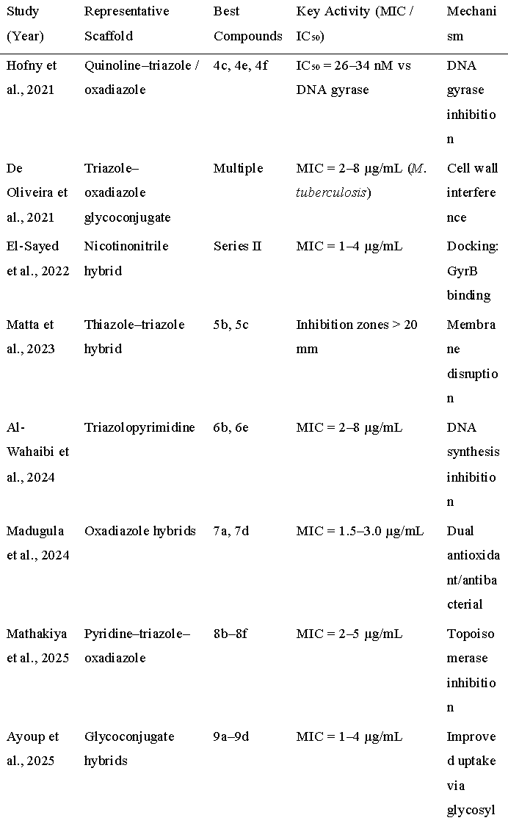
Table 1 comparative study on anti microbial evalution based on the recent literature

11. Mechanistic Insights:
Docking and enzyme inhibition studies confirm DNA gyrase/topoisomerase IV as primary targets for most hybrids (Hofny 2021, Agarwal 2025). Hydrogen bonding interactions with Asp81, Glu85, and Tyr123 in the GyrB subunit are consistent across studies. Some derivatives (Madugula 2024) also display radical scavenging, suggesting dual antimicrobial and antioxidant profiles.

Structure–Activity Relationship (SAR)
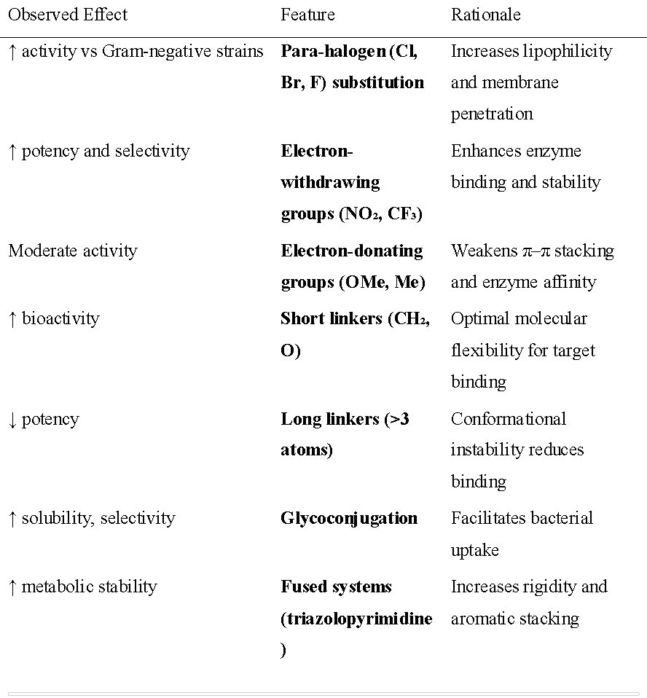
Table 2 structure activity relationship (SAR)

Table 2 comaparitive study shows the effect of different substituent on the activity

ADME and Toxicity Predictions
Most hybrids satisfy Lipinski’s Rule of Five (MW < 500, logP < 5, HBD ≤ 5, HBA ≤ 10). Computational screening (De Oliveira 2021, Al-Wahaibi 2024) predicts high oral bioavailability and low cytotoxicity (CC₅₀ > 50 µM).

13. Conclusion

Triazole and oxadiazole hybridization provides a rational route for developing potent, broad-spectrum antimicrobial agents. The period 2021–2025 has yielded potent leads, many with MIC values below 5 µg/mL. Structural optimization, mechanistic validation, and exploration of new hybrid combinations (e.g., coumarin-, indole-, and quinoline-linked systems) are the next logical steps.

14. Scope of Further Work
Future research should emphasize the following areas:
• Advancing the most promising leads to **ADME/toxicity** studies and in vivo infection models.
• Mechanistic studies using proteomics and enzyme inhibition assays to identify precise molecular targets.
• Exploration of antibiofilm optimization through hydrophilic/lipophilic balance adjustment.
• Integration of AI and QSAR modeling to predict and optimize antimicrobial potency.
• Continued efforts toward green and scalable synthesis (e.g., flow chemistry and catalysis).

References
1Addo, J.K., Tetteh, P., Mensah, M.A., et al., 2022.
Synthesis of 1,2,3-triazole-thymol derivatives as potential antimicrobial agents. Heliyon, 8(10), e10836. https://doi.org/10.1016/j.heliyon.2022.e10836
Agarwal, A., Sharma, V., Kumar, V., et al., 2022.
Design, synthesis, and biological evaluation of ciprofloxacin-tethered 1,2,3-triazole conjugates as antibacterial agents. ACS Omega, 7, 13675–13688. https://doi.org/10.1021/acsomega.1c05303
Ali, A., Shah, S.A.A., Khan, M., et al., 2021.
Development of oxadiazole-sulfonamide-based compounds as potential antibacterial agents. ACS Omega, 6(42), 27798–27813. https://doi.org/10.1021/acsomega.1c03379
Ashok, D., Ramesh, A., Srinivas, K., et al., 2023.
Synthesis, characterization and antimicrobial activity of novel 1,2,3-triazole-based carbazole derivatives. RSC Advances, 13, 2060–2071. https://doi.org/10.1039/D2RA05960F
Avula, S.K., Boddu, V.M., Gollapalli, M., et al., 2021.
Synthesis and antimicrobial activity of 1H-1,2,3-triazole and carboxylate analogues of metronidazole. Beilstein Journal of Organic Chemistry, 17, 1885–1900. https://doi.org/10.3762/bjoc.17.154
Chathangad, S.N., Patel, V.M., Desai, N.C., et al., 2024.
Mitigating antimicrobial resistance through strategic design of 1,2,3-triazole hybrids. ACS Biomed. Chem. Au. https://doi.org/10.1021/acsbiomedchemau.4c00132
Douglas, E.J.A., Jackson, P., Hill, R., et al., 2023.
Improved antibacterial activity of 1,3,4-oxadiazole-based compounds. ACS Infectious Diseases, 9, 2680–2693. https://doi.org/10.1021/acsinfecdis.3c00250
Figueroa, L.P.R., Da Silva, J.M., Araujo, T., et al., 2023.
Synthesis and evaluation of antibacterial activity of 1,2,3-triazole ether derivatives of paeonol. Journal of the Brazilian Chemical Society, 34, e20220085. https://doi.org/10.21577/0103-5053.20220085
Glomb, T. and Świątek, P., 2021.
Antimicrobial activity of 1,3,4-oxadiazole derivatives. International Journal of Molecular Sciences, 22, 6979. https://doi.org/10.3390/ijms22136979
Khamkar, T., Gawande, S., Joshi, R., et al., 2025.
Recent advances in synthetic approaches for 1,3,4-oxadiazole derivatives: a comprehensive review on therapeutic applications. Open Medicinal Chemistry Journal, 19. https://doi.org/10.2174/0118741045372896250619051210
Khasawneh, H.E.N., Al-Tel, T.H. and Al-Qawasmeh, R., 2025.
Unveiling the therapeutic potential of 1,2,4-oxadiazole derivatives: an updated review (2018–2024). Results in Chemistry, 15, 102271. https://doi.org/10.1016/j.rechem.2024.102271
Kurup, S.S. and Jat, R.K., 2023.
A review exploring therapeutic effect of 1,3,4-oxadiazole compounds. Journal of Drug Delivery and Therapeutics, 13(10), 147–148. https://doi.org/10.22270/jddt.v13i10.5979
Manachou, M., El-Masry, A.H., Fahmy, A., et al., 2024.
Antibacterial lead identification of novel 1,3,4-oxadiazole derivatives based on molecular computer-aided design approaches. Scientific African, 23, e02078. https://doi.org/10.1016/j.sciaf.2024.e02078
Matta, R., Al-Harrasi, A., Shah, A., et al., 2023.
Synthesis, antimicrobial and antioxidant activity of triazole, pyrazole containing thiazole derivatives and molecular docking studies. BMC Chemistry, 17, 61. https://doi.org/10.1186/s13065-023-00965-8
Patel, U.K., Chaudhari, P.S., Patel, N.B., et al., 2024.
Synthesis of ciprofloxacin-linked 1,2,3-triazole conjugates as potential antimicrobial agents. RSC Advances, 14, 11621–11633. https://doi.org/10.1039/D4RA01332H
Rao, G.V., Kumar, K.A., Reddy, C.S., et al., 2023.
Synthesis, antimicrobial activity, and in silico studies of fluoroquinolones bearing 1,3,4-oxadiazolyl-triazole derivatives. Journal of Heterocyclic Chemistry, 60, 1517–1534. https://doi.org/10.1002/jhet.4700
Rashdan, H.R.M., Abdelmonsef, A.H., Shehata, I.A., et al., 2021.
Antibacterial activities and molecular docking of novel sulfone bis-compound containing bioactive 1,2,3-triazole moiety. Molecules, 26, 4817. https://doi.org/10.3390/molecules26164817
Rasras, A.J., Al-Qawasmeh, R.A. and Lataifeh, A.R., 2022.
Cholyl 1,3,4-oxadiazole hybrid compounds: design, synthesis and antimicrobial assessment. Beilstein Journal of Organic Chemistry, 18, 631–638. https://doi.org/10.3762/bjoc.18.63
Razzaq, A.S. and Nahi, R.J., 2021.
In vitro evaluation of antioxidant and antibacterial activities of new 1,2,3-triazole derivatives containing 1,2,4-triazole ring. Systematic Reviews in Pharmacy, 12(1), 196–200. https://doi.org/10.31838/srp.2021.1.31
Saeed, S., Rizwan, K., Zafar, A., et al., 2024.
Exploring theophylline-1,2,4-triazole tethered N-phenyl acetamides as antimicrobial agents: synthesis, biological evaluation and docking studies. Frontiers in Chemistry, 12, 1372378. https://doi.org/10.3389/fchem.2024.1372378
Sekhar, M.M., Reddy, K.H. and Venkatesh, G., 2018.
Synthesis and antimicrobial activity of pyrimidinyl 1,3,4-oxadiazoles, 1,3,4-thiadiazoles and 1,2,4-triazoles. European Journal of Medicinal Chemistry, 145, 1–10. https://doi.org/10.1016/j.ejmech.2017.12.067
Song, X., Li, Z., Li, D., et al., 2018.
Synthesis and investigation of the antibacterial activity and action mechanism of 1,3,4-oxadiazole thioether derivatives. Pesticide Biochemistry and Physiology, 147, 11–19. https://doi.org/10.1016/j.pestbp.2017.10.011
Strzelecka, M., Śliwinski, W. and Wyszogrodzka, G., 2021.
1,2,4-Triazoles as important antibacterial agents. Pharmaceuticals, 14, 224. https://doi.org/10.3390/ph14030224
Sucman, N., Birsan, M., Doria, G., et al., 2024.
New 1H-1,2,4-triazolyl derivatives as antimicrobial agents: synthesis, biological and in silico evaluation. Chemistry & Biodiversity, 21(5), e202400316. https://doi.org/10.1002/cbdv.202400316
Tian, G., Zhang, H., Liu, X., et al., 2023.
Recent advances in 1,2,3- and 1,2,4-triazole hybrids as antimicrobials and their SAR: a critical review. European Journal of Medicinal Chemistry, 259, 115603. https://doi.org/10.1016/j.ejmech.2023.115603
Tiwari, D., Yadav, S. and Pathak, D., 2022.
1,3,4-Oxadiazole derivatives as potential antimicrobial agents. Chemical Biology & Drug Design, 100, 1086–1121. https://doi.org/10.1111/cbdd.14100
Tok, F., Cakmak, O. and Genç, S., 2022.
Synthesis of some novel 1,3,4-oxadiazole derivatives and evaluation of their antimicrobial activities. Synthetic Communications, 52, 4280–4290. https://doi.org/10.1080/00397911.2022.2060751
Todorov, L., Krasteva, M. and Banfi, E., 2023.
1,2,3-Triazoles and their metal chelates with antimicrobial activity: A mini-review. Frontiers in Chemistry, 11, 1247805. https://doi.org/10.3389/fchem.2023.1247805
Upadhyay, D.B., Gupta, A., Verma, P., et al., 2025.
Antimicrobial efficacy of 1,2,3-triazole-incorporated indole derivatives. ACS Biomed. Chem. Au. https://doi.org/10.1021/acsbiomedchemau.4c00060
Xu, C., Wang, Y., Zhang, X., et al., 2024.
Synthesis of new 1,2,3-triazole derivatives and their potential antibacterial and biofilm inhibition activities. Frontiers in Chemistry, 12, 1473097. https://doi.org/10.3389/fchem.2024.1473097

