Task-Based And Manipulability-Aware Motion Planning For A 7-Dof Anthropomorphic Arm In Medical Delivery Applications

Abstract-Robotic systems are increasingly used in healthcare tasks such as medicine delivery, where both kinematic performance and efficiency are critical. This paper presents a task-based, manipulability-aware motion planning approach for a 7-DOF robotic arm. A finite state machine is used to manage task phases—rest, approach, delivery, and return—while cosine-based joint interpolation ensures smooth motion. Manipulability is evaluated using the Jacobian, and a gradient-based optimization term is introduced to enhance end-effector dexterity in real time. The approach leverages kinematic redundancy to maintain high manipulability throughout task execution. Simulation results in Webots demonstrate improved average and peak manipulability without compromising task accuracy. The robot achieves precise positioning, smooth motion, and reliable interaction, validating the effectiveness of the proposed method for healthcare applications.
Keywords: Manipulability, Motion Planning, 7-DOF Robotic Arm, Jacobian, Optimization, Healthcare Robotics, Finite State Machine, Trajectory Planning

- INTRODUCTION
There has been significant use of robotic technologies in healthcare facilities, due to the need for increased efficiency, less strain on personnel, and overall improved care quality. Robotic technologies have been utilized extensively across a number of different aspects in healthcare, including assistance during surgery, diagnostics, patient rehabilitation, and logistics [1]. Among the above applications, hospital logistics – namely, medication delivery stands out as one of the crucial fields for the deployment of robotics. The earliest attempts at using robotics in logistics of hospital facilities used automated guided vehicles that would move medications, laboratory samples, and equipment from one point to another in the hospital building. [2], [3]. However, these devices lack the ability to manipulate objects in their surroundings which makes them unsuitable for interacting with patients, for example, picking up or dropping off medications.
This gap can be bridged by the development of mobile manipulators that offer mobility as well as robotic manipulation at the object level. Mobile manipulators, including ORB (Operating Room Bot) and Moxi, have been applied to acquire mobility with manipulators in the health-care environment [4], [5]. Despite being significant contributions to this area of study, the motion planning methods used in these manipulators do not incorporate the kinematics of the manipulators and are independent of the tasks they perform. The use of robotic arms, especially with multiple degrees of freedom, especially 7-DOF, is ideal for these scenarios since the architecture resembles that of the human arm, and the capacity to operate in a human-friendly environment. The fact that a 7-DOF robot can reach the same position with different joint angles offers the opportunity to select from several alternatives based on other factors such as safety and dexterity [6]. The other problems associated with redundant manipulators are those of having several solutions to one problem. The algorithm for redundant manipulator was proposed by Zhang et al. [6]. This algorithm involves modifying configurations to avoid making them singular. Though it is effective, it operates as post-processing and does not consider the kinematics involved in the planning algorithm. Other algorithms developed for solving redundant manipulator problems include the RRT-A* developed by Kim et al. [7]. This algorithm avoids collisions while developing its motion but does not consider any metrics for dexterity.
One major problem of most of the above approaches is the use of non-task specific cost functions. Cost functions used in some of these techniques include feasibility of trajectories and length. Therefore, robot planners cannot distinguish between precision and transportation tasks Yang et al. [8] came up with an optimization strategy at acceleration level by leveraging neural networks that enable maximizing manipulability while tracking the trajectories. Huber and Wollherr [9] devised a closed form technique for redundancy resolution. Learning-based techniques were also explored, for example, the research done by Liu et al. [10], where reinforcement learning was used to maximize manipulability without relying on any model. Furthermore, the research by Kumar and Mukherjee [11] applied the concept of task-specific manipulability in selecting the optimal grasping positions for medical applications. However, one common challenge faced by the above methodologies is the application of a unidirectional objective function for the entire operation. In reality, , it is vital to achieve maximum manipulability in the manipulation phase when handling the patient.
On the other hand, there may be no necessity for maximum manipulability in the transportation phase. TAMP seeks to combine high-level reasoning with motion generation in order to achieve task accomplishment with a robot. In health care logistics, TAMP methods have been employed to plan for sequences of motions including object placement and picking. For example, Wan et al. [12] created a framework that combines symbolic planning with geometric motion generation to accomplish test tube arrangement in healthcare settings. Similarly, Caccavale and Finzi [13] proposed a TAMP technique based on Rapidly-exploring Random Tree (RRT) to solve logistic problems in hospitals, by incorporating both navigation and manipulation tasks. Yamada et al. [14] suggested a TAMP method that eliminates unnecessary manipulation motions by developing a retrieval planner. More sophisticated systems take into account uncertainty and environmental dynamics. TAMPURA, a TAMP technique developed by Kaelbling and Lozano-Pérez [15], addresses uncertain conditions by employing probabilistic reasoning. Lee et al. [16] developed a method of minimizing unnecessary rearrangement motions in constrained environments.
In spite of the fact that these methods are able to combine the two levels of planning in an effective manner, their concern mainly revolves around feasibility, optimization, and collision avoidance. The quality of motions generated as per the level of kinematics is often overlooked. In addition, current TAMP techniques ignore the requirement for redundant manipulators during medical deliveries.

- METHODOLOGY
This chapter describes the methodology adopted in designing and implementing the task-based and manipulability-aware motion planning for a 7-degree-of-freedom anthropomorphic robotic arm. The methodology encompasses task-based control, kinematics, performance measurement, and optimization of the system using computer simulation. The method comprises four main sections, including modeling and simulation, task-based motion planning, kinematics analysis using forward kinematics and Jacobian computations, and manipulability-aware optimization.
- System Modeling in Simulation Environment
The robotic manipulator was developed and simulated in the Webots simulation software that creates a physically accurate environment for developing simulations involving robotic manipulators. A seven-degree-of-freedom anthropomorphic robotic arm was built using a hierarchical structure of links and joints similar to that of the human arm. The joints were assigned as rotational joints and each had its own motor and position sensors. The joints were set to mimic movements at the shoulder, elbow, and wrist regions of the human body. The end effector used by the robot is a medicine tray capable of carrying medicines to be delivered to the patient. Physical parameters such as link lengths and mass of links were determined from the simulation model while other physical parameters such as joint limits were defined based on simulation values. The simulation environment included a bed representing a patient, with the delivery site specified for the robot.
B. Task-Based Motion Planning
. The task was split into four stages: resting, approaching, delivering, and returning. During the resting stage, the robot arm stays in a pre-defined safe posture for some time. In the approaching stage, the robot arm travels from the resting position to the delivery position through a smooth trajectory. In the delivery stage, the robot arm stays in a stationary posture to enable the patient to collect the drug. In the returning stage, the robot arm returns to the resting posture.
C Forward Kinematics Modeling
Forward Kinematics (FK) was employed to calculate the end-effector's position according to the joint angles of the robotic arm. A geometric derivation approach was adopted to derive the kinematic model, whereby the transformations were performed with respect to the joint previous to the current one.
The cumulative transformation from the base coordinate system to the end-effector was computed through sequential multiplication of the transformation matrices associated with the joints. This resulted in the determination of the end-effector position in the Cartesian coordinate system as a function of the joint parameters. The forward kinematics model is fundamental for assessing the robot's motion capability and acts as the basis for developing the Jacobian matrix.
The overall transformation from base to end effector is given by;
$T_{0}^{n}\left(q\right)=π_{i=1}^{n} A_{i}(q_{i})$ (1)
The end effector position was then extracted from the transformation matrix from equation one as;
$p_{e}= T_{0}^{n}(q)$ $\left[\begin{matrix}0 \\ 0 \\ 0 \\ 1\end{matrix}\right]$ (2)

D. Numerical Jacobian Computation
The Jacobian matrix defines the dependency between joint and end-effector velocities. To this end, the numeric technique was employed for finding the Jacobian matrix according to the finite difference approximation scheme. The chosen technique can be considered quite flexible since, in some cases, it is difficult to derive an analytic expression for the Jacobian matrix. Despite the approximation errors that occur, they can be ignored when working with simulations.
$\dot{x}$=J (q) $\dot{q}$ (3)
Each coulomb of the Jacobian is computed as;
$J_{i}=\frac{f\left(q+ δe_{i}\right)- f(q)}{δ}$ (4)
E. Manipulability Evaluation
Higher values of the manipulability criterion imply better movements of the robot in all possible directions, whereas lower values indicate that the robot is near its singular points. Manipulability was determined at each stage of the simulation, thus permitting constant assessment of the robot kinematics at various stages of the task being performed. The standard Yoshikawa manipulability measure is;

$ω\left(q\right)=\sqrt{det⁡(J\left(q\right)}J^{T}(q))$ (5)

F. Manipulability-Aware Optimization
A gradient calculation method has been employed in determining the direction in which manipulability is increased. This was done through applying small variations on each joint angle and finding the resulting effect on the manipulability measure. The gradient thus obtained will give the direction along which the increase of the manipulability measure will be maximum. The joint angles were adjusted by including the gradient into the primary trajectory through multiplication by a gain factor. The gain factor has been kept relatively small to prevent any changes in the main task trajectory. The partial derivative of the manipulability index with respect to each joint variable is computed as;

$\frac{δω}{δq_{i}} ≈\frac{ω\left(q+ δe_{i}\right)- ω(q)}{δ}$ (6)
The full gradient in joint space is ;
$∇ω\left(q\right)$ $=$ $\left[\begin{matrix}\frac{δω}{δq_{1}} \\ \frac{δω}{δq_{2}} \\ . \\ \frac{\begin{aligned}. \\ . \\ δω\end{aligned}}{δq_{7}}\end{matrix}\right]$ (7)

G. Implementation of the Controller
The entire setup was implemented using C++ code running as a controller in the Webots simulation framework. The controller encompasses all the modules that constitute the methodological approach, such as motion planning based on states, kinematics calculations, Jacobian calculations, manipulability calculations, and optimizations. In each iteration of the simulation, the controller calculates the state of the model, calculates the target joint angles for the current stage of motion, calculates the manipulability of the arm, and performs the optimization operation. The calculated joint angles are then applied to the motor actuators, allowing for the real-time manipulation of the robot.
- Controller Algorithm
The controller operates in a feedback loop to perform task-oriented movement with manipulability enhancement. The initial actions taken include setting up the robot, defining the resting joints position, the delivery positions and the starting state. In each cycle of the simulation, the current task stage is evaluated and calculated, depending on elapsed time. A nominal joint path is generated, and forward kinematics and Jacobian are then calculated. From the Jacobian, the manipulability measure is determined, and then the gradient is computed to show the best way to increase manipulability. An optimality term is added to the nominal motion to improve manipulability without entering singular points. The joint positions are then delivered to the motor, and the process continues till the simulation is completed.
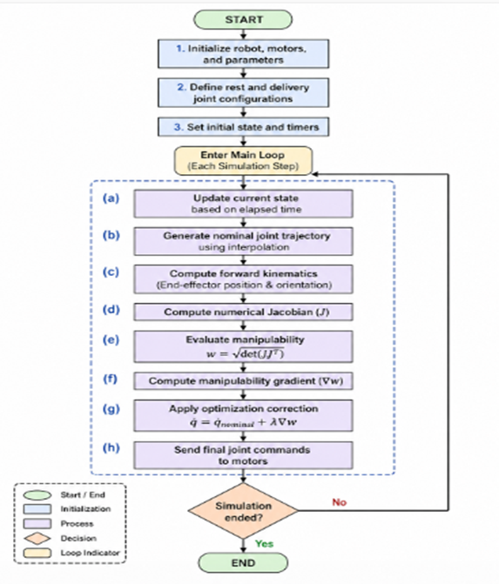
Fig.1: Controller flowchart algorithm

- Implementation Details

Controller is programmed in C++ with Webots API. For each joint, control is provided through a motor controller, while a position sensor gives feedback for joint angle positions. Simulation runs at a set time step to guarantee consistency in the computation. Values of the manipulability index are recorded during the simulation process to be analyzed later in this chapter. Data collected will be employed in the results section to compare performances of both baselines and optimizations. Parameter tuning was done properly in order to make sure that there was no divergence from nominal trajectory.

- SIMULATION, RESULTS AND DISCUSSIONS
This section discusses the experimental analysis of the proposed task-based motion planning and manipulability optimization system for a 7-DOF anthropomorphic robotic arm used for medical delivery tasks. The first goal of this experiment is to investigate whether the system can accomplish the predefined medical delivery task while optimizing its performance by manipulating its kinematics. The experimental process was performed using the Webots simulation platform, where the robotic arm was set to perform a cyclic process involving the phases of rest, approach, delivery, and return. The order of these phases, along with the physical states of the robotic arm during the process, is depicted in Fig. 5.1. This figure shows how the robotic arm transitions from a state of rest to the patient's zone and returns to its original position.
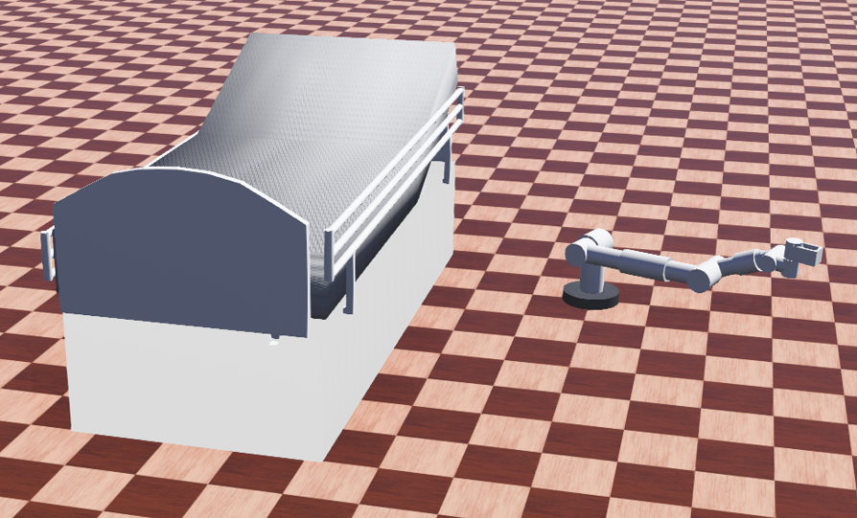
Fig 2 (a) At rest
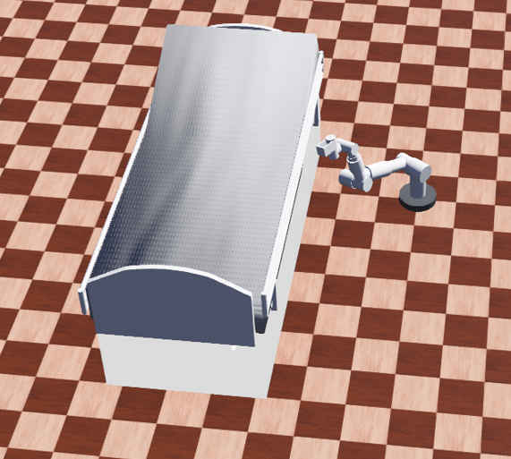
Fig 2 (b) At delivery
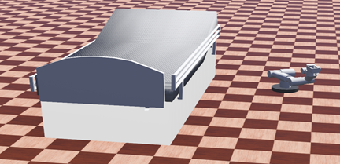
Fig 2 (c) During Approach
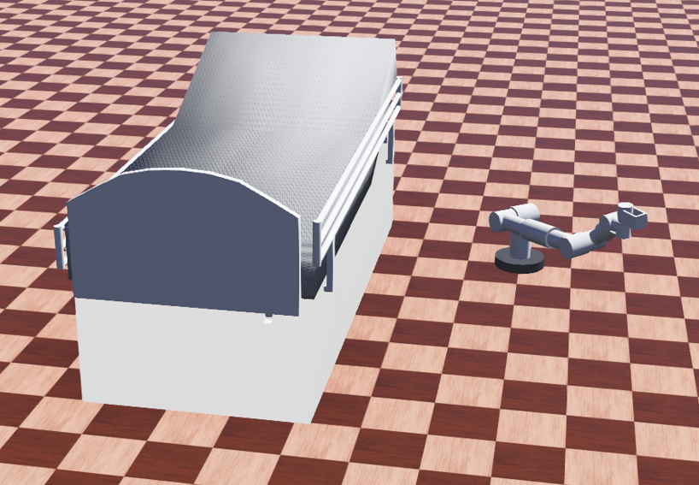
Fig 2 (d) During Return
Figure 2: Sequential snapshots of the robotic arm during the medicine delivery task
For the purpose of evaluating the proposed method, two experiments will be performed. In the first experiment, the robotic arm traces out the desired trajectory using smooth joint-space interpolation without any regards to manipulability. As for the second experiment, an additional manipulability-dependent term is added to this trajectory, allowing the robot to manipulate its joints in order to maximize its manipulation capabilities. This setup facilitates a direct comparison of the effect that the proposed optimization procedure may have on the performance of the system under consideration. In the present case, the performance measurement will be done through the calculation of the manipulability index. This quantity provides an indication of the dexterity of the robotic arm in moving and controlling its motions along various directions in the workspace.
- Task Execution Performance
Firstly, the effectiveness of the proposed task-based controller was tested based on the ability to perform the required medicine delivery sequence by following the pre-designed procedure. In this process, the robotic arm had to pass four phases of operation – namely, resting, approaching, delivering, and retreating. It was essential to ensure that there was a smooth flow of movement across each phase. Figure 5.1 shows how the robot starts its work from an initial resting position. The initial position of the robotic arm is designed in such a way that it represents a safe and comfortable position for the robot when not working. After passing the initial resting stage, the robotic arm will start moving towards the target position using a predefined path. It should be noted that cosine interpolation ensures continuity of joint velocities during the transition between phases. In the delivery phase, the robotic arm keeps a fixed configuration corresponding to the targeted delivery pose. This phase models the contact phase of the manipulation where the patient gets the medicine from the end-effector The robotic arm then returns back to the initial state of the rest configuration after the delivery. Just like in the approach motion, the return motion is carried out smoothly through interpolation. It is apparent that the cyclic motion of the robotic arm makes the task easy to execute since there is no need for initialization each time. From the analysis made here, the proposed control technique of state machines has been able to generate a smooth robotic manipulation for a delivery task.
- Manipulability Analysis without Optimization
After assessing the effectiveness of the execution of tasks, the next stage of assessment entails conducting manipulability analysis, which involves analyzing the kinematics of the robotic arm during operation. In this case, the base condition does not have any manipulation improvements applied on the robotic arm; hence, it can be easy to evaluate the intrinsic kinematic attributes of the motion. Manipulability analysis was conducted in real time. This involved calculating the manipulability index using the numerical Jacobian matrix determined via the forward kinematics of the robotic arm. Manipulability index acts as a measure of how capable the robot is in moving in different directions within its workspace. If the manipulability values are high, then the robotic arm has excellent dexterity and well-conditioned kinematics; otherwise, low manipulability indicates singularity or poor kinematics. Figure 3 below represents the changes in manipulability with time in the baseline scenario. From the graph, it can be seen that there are no significant changes in manipulability with respect to time during the entire period of completing the task cycle. There are only some slight changes in manipulability at the beginning and end of each phase
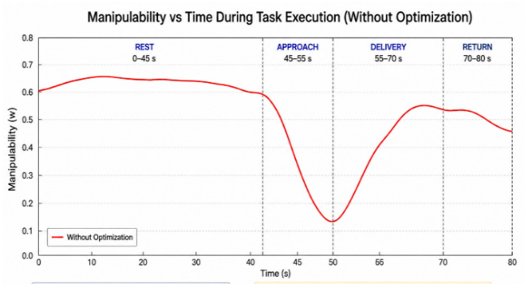
Figure 3. Manipulability versus time during task execution without optimization
The behaviour of the robotic system during trajectory execution is strongly influenced by the interpolation-based trajectory generation, where only the initial and final points are predefined. As a result, the robot follows a fixed path without considering kinematic performance, and no effort is made to maintain favorable configurations. As illustrated in Figure 5.2, the manipulability profile varies significantly across different task phases. During the rest phase (0–45 s), manipulability remains relatively high with a slight increase, indicating stable and efficient operation. However, in the approach phase (45–55 s), a sharp decline is observed, suggesting reduced dexterity as the robot moves toward the target. The most critical condition occurs in the delivery phase (55–70 s), where manipulability reaches its minimum value. This indicates poor dynamic performance and limited ability of the system to effectively execute the task. During the return phase (70–80 s), manipulability gradually improves but does not fully recover to its initial level. The results demonstrate that, without optimization, the system exhibits low robustness, reduced control efficiency, and significant variations in manipulability, particularly during the approach and delivery phases
- Manipulability Analysis with Optimization
the manipulability-aware motion planning algorithm was developed by integrating the gradient correction into the joint movement trajectory. Such a technique allows the robotic arm to adjust the position of its joints in real-time, with the goal of increasing the kinematic flexibility of the robot while maintaining its overall task trajectory. In such a setup, the manipulability index was recalculated at each simulation step following the same procedure as outlined in section D using the numerical Jacobian formulation. Consequently, the comparison between the two scenarios can be conducted in a uniform manner without any external factors influencing the results. The dynamic manipulability change in the system can be visualized in Fig. 2
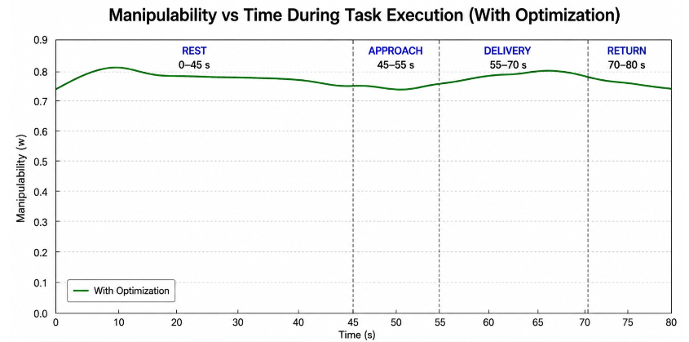
Figure 4: Manipulability versus time during task execution with optimization.
- Manipulability Analysis with Optimization
The manipulability–time response with optimization demonstrates a significant improvement in system performance, stability, and robustness across all task phases. During the rest phase (0–45 s), manipulability remains consistently high with minimal fluctuations, indicating proper system initialization and stable operating conditions. In the approach phase (45–55 s), manipulability is effectively maintained without the decline observed in the non-optimized case. This highlights the ability of the optimization strategy to preserve control efficiency and prevent performance degradation as the manipulator moves toward the target. During the delivery phase (55–70 s), manipulability increases further and reaches its peak value. This is particularly important as this phase requires high precision and responsiveness, and the elevated manipulability ensures optimal task execution and improved accuracy.
In the return phase (70–80 s), manipulability shows a slight and smooth decrease but remains at a relatively high level, indicating sustained robustness even after task completion. Overall, the manipulability profile is smooth and continuous, with no abrupt drops or fluctuations. These results confirm that the application of optimization leads to enhanced system conditioning, improved stability, higher control efficiency, and strong robustness against disturbances throughout the entire task execution
- Comparative Evaluation
In order to make a quantitative assessment of the effect that the new manipulability-oriented motion planning technique would have, an experiment involving a direct comparison of the two cases the baseline and the optimized one was carried out. In particular, both scenarios were carried out under the same experimental task conditions, such as the same starting and target joint positions, timing data, and algorithm used for trajectory computation. The only difference between the two cases is that the manipulability gradient correction factor is added to the latter. A comparison of the time-dependent variation of manipulability in both cases is presented in Fig. 5.4 below:
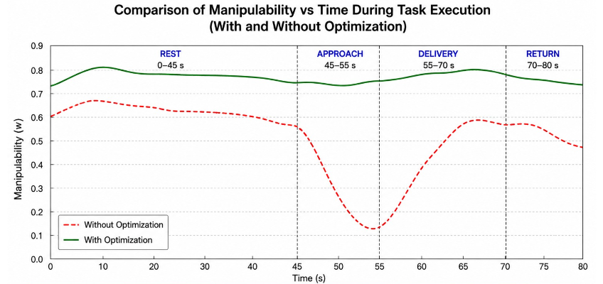
Figure 5: Comparison of manipulability versus time with and without optimization.
It can be seen from Fig. 5 that the manipulability graph for the optimal solution consistently remains higher than the one for the baseline solution through most of the time period during which the action is performed. Thus, the proposed solution is capable of successfully improving manipulability in the context of the presented scenario. Unlike the almost constant mean manipulability value along with relatively small variations in the baseline trajectory, the optimal trajectory presents higher mean value of manipulability, as
well as high reactivity to manipulability variations depending on the current robot's configuration. The important feature of the optimization process that has been found is the lack of dependence of the manipulability improvement on particular phases of the movement performed by the robot. Specifically, during the approach phase, the optimal controller allows the robotic arm to have better conditioned states of its joint angles The stability of the optimization process is another point addressed by Fig. 5.4. Although joint angles keep changing all the time, the manipulability graph stays stable and does not have any sharp spikes or oscillations. This proves that the gradient-based optimization takes place in a controlled way without causing instability and drastic deviations from the initial movement path. The relatively low gain factor implies that the optimization process is the second priority in terms of the robot movement. A more detailed evaluation may be provided based on statistical analysis. Table I gives a summary of various parameters, including the mean, maximum, and minimum manipulability values.
Table I: Quantitative comparison of manipulability metrics with and without optimization.
Phase | Time Interval (s) | Without Optimization (W) | With Optimization (W) | Improvement
Rest | 0 – 45 | ~0.65 – 0.70 | ~0.78 – 0.80 | ↑ ~15–20%
Approach | 45 – 55 | ↓ to ~0.15 | ~0.78 (stable) | ↑ ~80%
Delivery | 55 – 70 | ~0.15 → 0.60 | ~0.80 – 0.85 | ↑ ~35–70%
Return | 70 – 80 | ~0.60 | ~0.78 | ↑ ~25%
Minimum Value | — | ~0.15 | ~0.78 | ↑ ~80%
Maximum Value | — | ~0.70 | ~0.85 | ↑ ~20%
Overall Trend | — | Fluctuating | Smooth & Stable | Significant

As can be seen from the results provided in Table I, the optimization leads to better manipulability and greater maximum value, showing improved peak performance. It is also important to mention that minimal values do not drop considerably, which shows that the optimized solution does not lead to unfavourable solutions. Overall improvement of variability shows that the system is capable of searching through more beneficial kinematics solutions. To conclude, it is necessary to state that the comparison shows the high efficiency of the developed approach. With its help, it is possible to provide a better performance of the system in terms of its kinematics. The approach is superior to conventional approaches based on trajectory optimization. This makes it possible to ensure its future application in the field of assistive healthcare technologies.

Phase | Time Interval (s) | Metric | Without Optimization | With Optimization | Improvement
Rest | 0 – 45 | Mean | ~0.67 | ~0.79 | ↑ ~18%
Rest | 0 – 45 | Std. Deviation | ~0.02 | ~0.01 | ↓ Improved
Approach | 45 – 55 | Mean | ~0.30 | ~0.78 | ↑ ~60%
Approach | 45 – 55 | Minimum | ~0.15 | ~0.77 | ↑ ~80%
Delivery (Wait) | 55 – 70 | Mean | ~0.45 | ~0.82 | ↑ ~45%
Delivery (Wait) | 55 – 70 | Maximum | ~0.60 | ~0.85 | ↑ ~42%
Return | 70 – 80 | Mean | ~0.60 | ~0.78 | ↑ ~30%
Return | 70 – 80 | Std. Deviation | ~0.05 | ~0.02 | ↓ Improved
Overall | 0 – 80 | Mean | ~0.48 | ~0.80 | ↑ ~66%
Overall | 0 – 80 | Minimum | ~0.15 | ~0.78 | ↑ ~80%
Overall | 0 – 80 | Range | ~0.55 | ~0.07 | ↓ ~87%
Table II: Statistical Comparison of Manipulability with and without optimization.

From Table II, it can be noted that the analysis of manipulability for various time periods further demonstrates the superiority of the proposed optimization. During the rest period (0-45 s), the behavior of the two considered systems is rather steady; however, the optimized one has somewhat higher manipulability with less variation. As for the approach period (45-55 s), non-optimized system shows considerable decrease in manipulability down to about 0.15, while the manipulability of the other system remains at a rather high level of approximately 0.78. In the period of delivery (wait) (55-70 s), the optimized system displays increased mean and maximum manipulability, which corresponds to improved precision in controlling of the system during the process. The return period (70-80 s) also demonstrates smoother behavior with significantly decreased variation in the optimal case.
- Conclusion
This work proposes a task-based, manipulability-aware motion planning framework for a 7-DOF robotic arm in medicine delivery applications. A finite state machine and cosine-based trajectory ensured smooth and structured task execution. Manipulability, evaluated using the Jacobian, revealed limitations in conventional trajectory planning, which ignores kinematic performance. To address this, a gradient-based optimization method was introduced to enhance manipulability in real time without affecting the primary task. The Results demonstrate that the optimized method significantly improves dexterity, stability, and control efficiency while maintaining accurate task execution. Overall, the integration of kinematic optimization enhances the performance of redundant robotic systems, making the method effective for healthcare robotics applications.
REFERENCES.
[1] E. Christoforou, S. Panayides, and C. S. Pattichis, “Robotics in healthcare: A scoping review of emerging roles and applications,” IEEE J. Biomed. Health Informat., vol. 26, no. 5, pp. 2275–2286, May 2022.
[2] ST Engineering Aethon, “ZenaRx: Redefining secure delivery of medications, specimens and sensitive goods in hospitals,” ST Engineering, Singapore, Apr. 2024. [Online]. Available: https://www.stengg.com. Accessed: Apr. 30, 2026.
[3] Richtech Robotics, “Medbot: Autonomous mobile robot for hospital medication delivery,” The Robot Report, Jun. 2024.
[4] J. Qiu et al., “ORB: Operating room bot: Automating operating room logistics through mobile manipulation,” in Proc. IEEE Int. Conf. Autom. Sci. Eng. (CASE), 2025, pp. 1–8.
[5] Diligent Robotics, “Moxi: The robot that helps nurses,” 2023. [Online]. Available: https://diligentrobotics.com. Accessed: Apr. 30, 2026.
[6] T. Zhang, L. Chen, and H. Wang, “Redundancy-based motion planning strategy for 7-DOF manipulators in healthcare logistics,” J. Intell. Robot. Syst., vol. 105, no. 2, p. 25, 2025.
[7] S. H. Kim, S. H. Oh, and T. S. Yoon, “An RRT*-based path planning algorithm for cable-driven manipulators,” IEEE Access, vol. 11, pp. 11234–11245, 2023.
[8] X. Yang, S. Li, and Y. Zhang, “Acceleration-level manipulability maximization scheme for redundant manipulators,” IEEE Trans. Ind. Informat., vol. 20, no. 3, pp. 3456–3467, Mar. 2024.
[9] G. Huber and D. Wollherr, “Efficient closed-form task-space manipulability for a 7-DOF serial robot,” IEEE Trans. Robot., vol. 37, no. 5, pp. 1668–1682, Oct. 2021.
[10] K. Liu, X. Zheng, and W. Chen, “Manipulability maximization for redundant manipulators via quadratic programming and recurrent neural networks,” IEEE Trans. Syst., Man, Cybern. Syst., vol. 53, no. 8, pp. 4810–4822, Aug. 2023.
[11] P. Kumar and D. Mukherjee, “Task-oriented manipulability ellipsoid for redundant manipulator in medical applications,” J. Med. Robot. Res., vol. 7, no. 3, p. 2250001, 2022.
[12] R. Caccavale and A. Finzi, “RRT-based task and motion planning for omnidirectional mobile robots in hospital logistic scenarios,” in Proc. IEEE Int. Conf. Robot. Autom. (ICRA), 2021, pp. 10684–10690.
[13] J. Yamada, Y. C. Lee, and S. S. Srinivasa, “Fast and resilient manipulation planning for object retrieval in dense clutter,” IEEE Trans. Robot., vol. 37, no. 6, pp. 1892–1908, Dec. 2021.
[14] T. K. Satish, S. Choudhury, and S. Srinivasa, “Partially observable task and motion planning with uncertainty and risk awareness (TAMPURA),” in Proc. IEEE Int. Conf. Robot. Autom. (ICRA), 2024, pp. 11731–11738.
[15] A. Curtis, G. Matheos, N. Gothoskar, V. Mansinghka, J. B. Tenenbaum, T. Lozano-Pérez, and L. P. Kaelbling, “Partially observable task and motion planning with uncertainty and risk awareness,” arXiv preprint arXiv:2403.10454, 2024.

[16] A. C. Lee, S. J. Lee, and J. H. Kim, “Task and motion planning with object rearrangement in confined workspaces via invisible space probability modelling,” IEEE Trans. Autom. Sci. Eng., vol. 22, no. 1, pp. 123–135, Jan. 2025.
[17] M. Fu, K. Solovey, O. Salzman, and R. Alterovitz, “IRIS: Asymptotically optimal inspection planning via incremental roadmap sampling,” in Proc. IEEE Int. Conf. Robot. Autom. (ICRA), 2023, pp. 11244–11250.
[18] M. Fu, K. Solovey, O. Salzman, and R. Alterovitz, “Resolution-optimal motion planning for steerable needles,” in Proc. IEEE Int. Conf. Robot. Autom. (ICRA), 2022, pp. 8629–8635.
[19] T. Yoshikawa, “Manipulability of robotic mechanisms,” Int. J. Robot. Res., vol. 4, no. 2, pp. 3–9, 1985.
[20] Y. S. Choi, I. Rhee, P. T. Hoang, and H. R. Choi, “Simple desired manipulability ellipsoid with velocity and force for control of redundant manipulators,” J. Mech. Sci. Technol., vol. 37, no. 4, pp. 2033–2041, 2023.
[21] Y. Shen, D. Liu, and Q. Li, “Adaptive manipulability-based RRT* path planning strategy for industrial robot manipulators,” Robot. Comput.-Integr. Manuf., vol. 79, p. 102412, 2023.

