Classification and Segmentation of Multiple Myeloma Cancer Cells Using Deep Neural Networks

Abstract: Multiple Myeloma is a type of blood cancer of plasma cells that can severely damage the bones and kidneys and can lead to death. For early-stage detection of this cancer, classification and segmentation of multiple myeloma cells via Computer-Aided Diagnosis (CADs) could be very helpful. We used Seg-PC 2021 challenge dataset consisting of microscopic images of stained cells, and their ground truth masks drawn for cancerous cells in the image by experts. Classification of cancerous and non-cancerous cells was performed using Convolutional Neural Networks along with Transfer Learning from several pre-trained Neural Networks as feature extractors, followed by a trainable dense classification layer. Our classification model achieved an accuracy of 97% on pre-trained MobileNet model training. For segmenting the cancerous cells into nucleus and cytoplasm, we used U-Net architecture, and achieved good performance with mean intersection over union (mIoU) of 86.03%.
Keywords: Multiple myeloma cancerous cells; Segmentation; U-Net; Classification; Transfer learning

Introduction
When plasma cells grow out of control in bone marrow and other parts of the body it takes the form of multiple myeloma. Multiple myeloma hinders the functioning of red blood cells, platelets, and other white blood cells. The overgrown cells affect kidneys and bones which lead to death. It is an incurable disease because of which its early detection is important [1].
Due to the difficulty in detecting cancerous cells from non-cancerous cells, their classification and segmentation are time-consuming, costly, error-prone, and require expertise. In these cases, it creates inter and intra-observer variation [2] and increases the chances of poor accuracy. Multiple Myeloma is an incurable disease whose earlier detection is important for cancer in order to improve the patient’s prognosis. In the last decade, Deep Learning based AI solutions have become increasingly powerful due to accessibility of large amounts of data for training the neural networks, and simultaneous growth in the computing hardware capabilities, especially Graphical Processing Units (GPUs) that speed up the network training due to large scale parallelization of computations. That is why computer-aided diagnosis can save time, cost and energy and reduce errors. Computer aided diagnosis has been successfully used for the early detection of cancer. Our research is an AI based CAD system that could perform classification as well as segmentation of the cancerous cells.
Various methods have been used for classification such as training a model from scratch, using the pre-trained model as a backbone and fine-tuning the last layers which are also called Transfer Learning [3]. It has been a successful approach for classification of cancerous cells and segmentation.
Many studies have applied Artificial Intelligence (AI) methods to segment cancerous cells from histopathological images. Problems such as the resemblance of cytoplasm with the background, poor staining of the cancerous cells, and partial segmentation of cancerous cells [4] are some of the factors that influence the precise segmentation of the plasma cells.
In our study, we used Transfer Learning for the classification of cancerous cells and U-Net for the segmentation of the cancerous cells. UNet [5] is a popular network architecture for the segmentation of biomedical images. We aim to segment the cancerous images in order to do the morphometry of the cells for the precise diagnosis of cancer that contributes to the healthcare of the patients.
This paper is structured as follows. First, we give a glimpse of the related work in scientific literature. Then we present the dataset and methodology used. Finally, we conclude our results with the main observations and conclusions.

Related work
Various methods have been introduced to classify and segment cancerous cells. For instance, in the case of classification, [6] proposed a method that could easily detect the presence of Multiple Myeloma cancerous cells. They took a sample of 1,741 multiple myeloma records from hospitals to create an early diagnosis tool. Another study [7] used the approach of transfer learning using pre-trained GoogleNet which is trained over three brain tumor datasets.

Similarly, in Segmentation, several models such as mask R-CNN, U-Net, Attention Deeplab3+, SAM1 [8] , SAM2 for medical images segmentation [9], SAM3 [10] have been introduced. For segmentation, [11] used Mask R-CNN as an architecture to segment multiple myeloma cancerous cells where they categorized three kinds of images and compared their model results with state of the art methods. They managed to segment out a cluster of cancerous cells. In another study [4], authors dealt with the noisy and ambiguous nature of the images. They used three architectures namely maskR-CNN, Hybrid Task Cascade (HTC), and SCNet for detection as well as segmentation of the masks. As a backbone for the feature extractor, ResNet and ResNest was used along with data augmentation and ensembling of the models to obtain appreciable mIoU.
Another study for the same Seg-PC dataset used a two-stage method [2]. In the first stage, they solely segment the nucleus part using U-Net architecture which was further propagated to the next step. The second step emphasized the cytoplasm’s boundary. The multi-scale instance is used to capture both small and larger boundaries of the cytoplasm which was their major concern for the dataset. From the masks produced by the multi-scale method, a final mask is formed using the aggregation function. Their study considered cytoplasm boundaries as a major problem.
Many methods have been proposed for segmentation and classification purposes using neural network architectures of increasing complexity which are time-consuming and computationally expensive. In this paper we show that even when using a basic U-Net architecture, we can still obtain good mean intersection over union (mIoU) [12].
Most studies have focused either on classification or segmentation of cancerous cells, but here we perform both classification as well as segmentation on the same dataset. The original dataset provided is shown in Fig. 1.

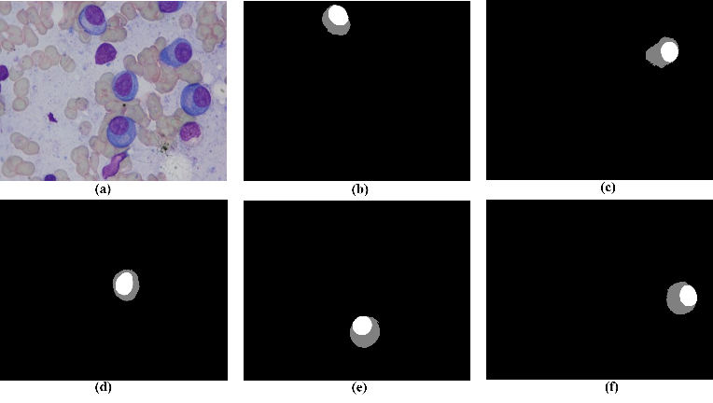
Fig. 1: Original plasma cancerous cells

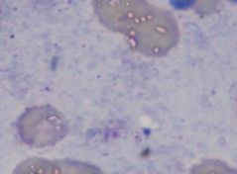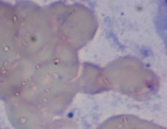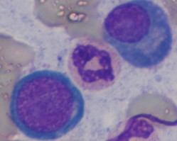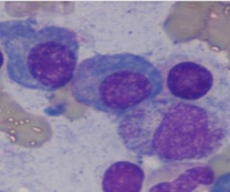
Fig. 2: Left two images are non-cancerous and right two images are cancerous

Materials and methods

Dataset
The data for the quantitative research was acquired from the challenged released SegPC-2021 [13]. The dataset had total of 775 images (298 images for training, 200 for validation, and 277 for testing). Data were annotated by experts where the nucleus, as well as cytoplasm, were labelled individually for plasma cancerous cells. Multiple Myeloma histopathological microscopic images were collected at AIIMS Hospital, New Delhi, India from Multiple Myeloma patients [14], [15]. Microscopic images were obtained from slides containing patients’ bone marrow aspirates. The staining agent used to stain the cancerous cells was Jenner-Giemsa agent. The dataset shown in Fig. 1 contains original image and their ground truths of the plasma cells having cancerous regions which was annotated by experts. A validation set was used for testing the accuracy of the classification and segmentation of the dataset. The dataset provided has high resolution images of 2560×1920 pixels per image illustrated in Fig. 1.
Computing hardware used for training the U-Net included a virtualization server running NVIDIA Virtual Compute Server, and Academic VMware Horizon 7 Enterprise with a 16 GB Nvidia Tesla T4 GPU with a pair of Xeon Silver (10 Cores @ 2.4GHz) processors and 96GB RAM. A 9th Gen 9700F 8 Core Processor, Core i7 workstation (16GB RAM and NVIDIA GTX 1650 4GB GPU) was used for pre-processing of the dataset and for routine tasks.

Methods
- Classification:
Before directly feeding the images to the network, pre-processing of the dataset is required. Since classification includes cancerous and non-cancerous region form the model training, two classes dataset was prepared manually by cropping the cancerous region and non-cancerous region from a single image in order to build a classifier as shown in Fig. 2. From a single original image, multiple sub images were created. If a sub-image contained a cancerous cell, the image was labelled “cancerous”, otherwise the image was labelled “non-cancerous”. Total images obtained were 1451 images containing 746 images with “cancerous” labels and 705 images with “non-cancerous” labels. From total 1451 number of images, 1100, 200, 151 images were kept for training, validation and testing respectively.
For Transfer Learning from a pre-trained network MobileNetV2 architecture was used. Input images were resampled to 160×160 image size as per pre-trained model requirements. As a pre-processing step image augmentation (reflecting, rotating and scaling) was to generate larger number of images from original images in order to avoid the over-fitting problem that usually occurs due to smaller number of training images. The data were normalized before sending them as input to the neural network. Base model of the MobileNetV2 architecture, acting as the feature structure, takes in 160×160×3 images and outputs a 5×5×1280 features block. The parameters of this feature extraction block were frozen and not changed during training process. After the feature extraction block, a flattening layer was added. The classifier block consisted of one flattened layer being fully connected with the output layer of two neurons for two class binary classification task. Out of 2,259,265 parameters in the whole neural network, only 1281 parameters kept trainable, since parameters in the feature extraction part from MobileNetV2 were frozen and hence non-trainable. A batch size of 32 was used with total of 100 epochs for training purpose.
Once the dataset was trained on the pre-trained neural network, fine-tuning approach is used to further enhance the performance of the model. The focus at this point is on high level of features instead of general features. Based on that, some of the top layers of the feature extractor block were unfrozen and again training for 200 epochs was done where fine tuning of model starts after 100 epochs. Segmentation:
- Segmentation:
Pre-processing for segmentation involves several steps before images could be input into the U-Net neural network. The Ground Truth masks provided had 0, 20, 40 numeric values for background, cytoplasm and nucleus respectively. During pre-processing, they were converted to 0, 1, 2 for background, nucleus and cytoplasm respectively. From original set of 2560×1920 RGB images, a final dataset of 1788 sub images and masks were prepared by computationally cropping them into 512x512 sized RGB images which were further resized into 256×256-pixel size in order to reduce computation load during segmentation as illustrated in Fig 3. Dataset cropping of images to 256×256 image size was used as a data augmentation tool in order to increase the dataset size. Data were split into training and validation sets with 80:20 ratio. image’s mask.
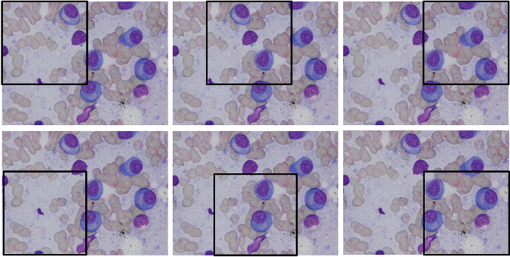
Fig. 3: Image cropping of 512×512 is done which was further resampled to 256×256 to reduce computation cost to increase the dataset
We used a U-Net Fig. 4 type architecture to segment the cancerous cells into cytoplasm, nucleus and background components. The U-Net based neural network consisted of down-sampling layers that extract the context of the input image whereas the up-sampling layers provide precise localization. It consisted of 23 convolutional layers each followed by pooling and dropout layers. The initial input images have 256×256 RGB images which are downsampled along the first half of the U-Net architecture to 16x16 image size. In the second half of the U-Net these images are upsampled back to 256×256 at the output layer where it emerges as the segmentation mask.

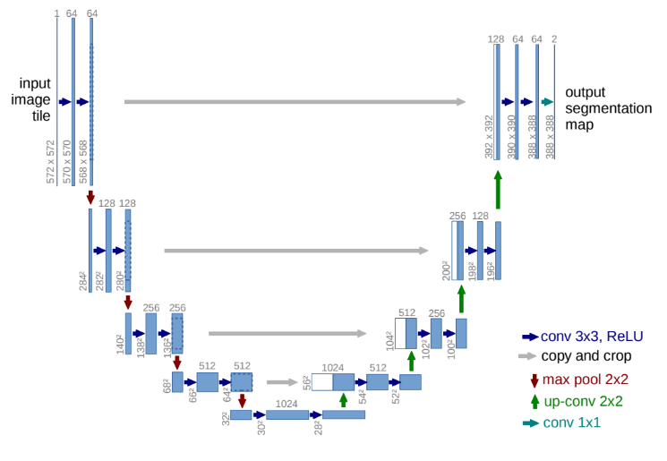
Fig. 4: Original U-Net architecture [5]
Images in our dataset consist of three components that require segmenting. Categorical Cross Entropy was used as a loss function for the training. Accuracy and Jaccard I ndex were used as evaluation metrics of the model.
A grid search approach was used for determining some optimum hyper-parameters during training. Different values such as 0.1, 0.001, 0.0001, 0.00001 were used for the learning rate that brought significant difference in the training results. The network undergoes varying batch size such as 8, 32, 64 and number of epochs from 100, 200, 400, 1000 to obtain the optimum results. Once the training was completed, no further post-processing was done.

results
In classification of the cancerous and non-cancerous region, fine-tuning actually enhanced the performance of the model giving more stability in the graph. Accuracy values achieved were 97% with loss value of only 0.08.

Classification
MobileNetV2 performance is shown by plotting a graph for model accuracy and loss in Fig. 5. Model shows an accuracy of 97% with reducing loss with little over-fitting.
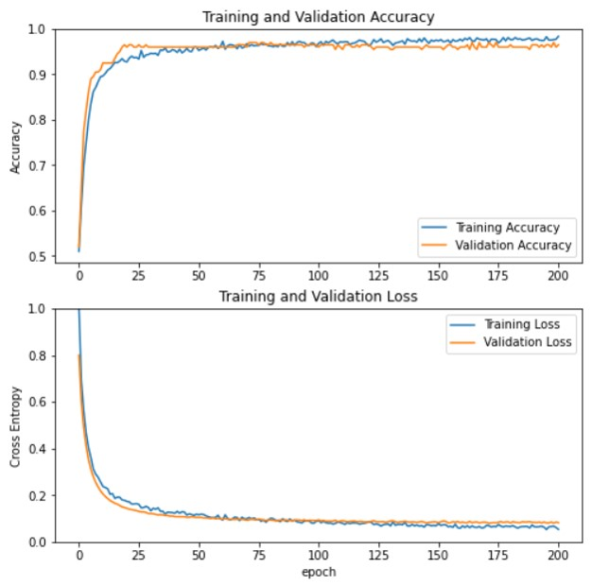
Fig. 5: Training and validation accuracy and loss for MobileNet-V2

Segmentation
Mean IOU is used for evaluating the performance of the model. Fig 6 shows the predicted masks on test dataset predicted by U-Net model.
The performance metrics for various hyper-parameter (dropout, learning rate, batch-size, number of epochs) choices are shown in TABLE I.
TABLE II shows the intersection over union of individual class thereby mentioning an imbalance in the dataset.
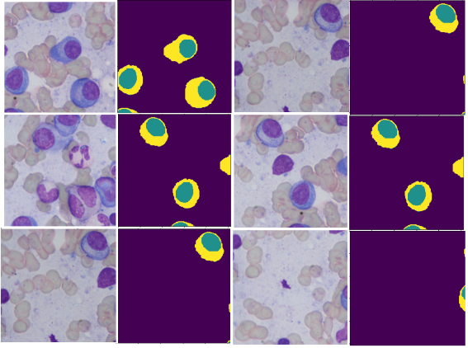
Fig . 6: Predicted results obtained from the trained U-Net architecture. First and third columns are the test images, second and fourth row are predicted masks of the respective images.

In this paper, we propose a complete deep learning framework for the classification and segmentation of Multiple Myeloma (MM) cancer cells using MobileNetV2 for classification and U-Net for semantic segmentation on the SegPC-2021 dataset. Our results show strong performance on both tasks, but there are several important points to consider regarding the dataset characteristics and limitations of the models that need to be discussed in detail. The results show good performance on both tasks, but there are several important considerations concerning dataset characteristics and model limitations that warrant a detailed discussion.

Classification
A classification model using MobileNetV2 was able to achieve a notable accuracy of 97% in distinguishing between Multiple Myeloma plasma cells and normal cells. The high classification accuracy demonstrates the potential for lightweight convolutional architectures, originally developed for mobile and embedded vision applications, to be applied to medical image analysis. The pre-trained MobileNetV2 backbone was fine-tuned on the SegPC-2021 dataset, enabling the model to leverage general visual features and adapt them to the specific morphological features of MM cells. Such high classification accuracy underlines the power of lightweight convolutional architectures, initially developed for mobile and embedded vision applications, in the field of medical image analysis. The pre-trained MobileNetV2 backbone was fine-tuned on the SegPC-2021 dataset, which allowed the model to adapt these general visual features to the specific morphological characteristics of MM cells.

Segmentation
The U-Net segmentation model achieved a mean Intersection over Union (mIoU) of 0.86, indicating good spatial localization of MM plasma cells in microscopic images. However, it is essential to consider these results in the context of the inherent challenges of the dataset. Cell boundaries in MM microscopy images often exhibit low contrast, irregular shapes, and overlapping cellular structures, leading to ambiguity in segmentation. The mIoU of 0.86, while competitive, also highlights the challenge of achieving perfect boundary delineation under these challenging conditions. However, it is important to put these results in context given the challenges inherent to the dataset. In MM microscopy images, the cell boundaries are usually low in contrast, irregular in morphologies and overlapped cellular structures that introduce ambiguity during the segmentation. Although the mIoU of 0.86 is competitive, it also shows the difficulty of perfect boundary delineation under such challenging conditions.

Limitation and future work
The proposed framework performs well, yet there is still room for improvement in several directions. One promising direction is the use of transformer-based segmentation architectures. Models such as Segment Anything Model (SAM) proposed by Meta AI, revolutionize the field of image segmentation by utilizing large-scale vision transformers with promptable segmentation functionality. Future work will explore the possibility of incorporating SAM and its domain-adapted versions (e.g., MedSAM) to the MM cell segmentation pipeline. One particularly promising direction is to use transformer-based segmentation architectures.

- experiments showing various miou obtained for various hyperparameters
Loss function | Dropout | Learning rate | Batch size | Epochs | Mean IoU
Categorical  Cross-entropy | 0.15 | 0.001 | 64 | 200 | 0.84
Categorical cross entropy | 0.2 | 0.001 | 16 | 400 | 0.86

Models like Meta AI’s Segment Anything Model (SAM) represent a paradigm shift in image segmentation, leveraging large-scale vision transformers with the ability to perform promptable segmentation. Future work will explore the integration of SAM and its domain adapted variants (e.g. MedSAM) in the MM cell segmentation pipeline.
- individual mean intersection over union of optimum mean iou
 | Label | IoU
1 | Nucleus | 80
2 | Cytoplasm | 81
3 | Background | 96

References

- J. F. San-Miguel and M.-V. Mateos, “Can multiple myeloma become a curable disease?,” Haematologica, vol. 96, no. 9, pp. 1246–1248, Sep. 2011, doi: 10.3324/haematol.2011.051169.
- A. Bozorgpour, R. Azad, E. Showkatian, and A. Sulaiman, “Multi-scale Regional Attention Deeplab3+: Multiple Myeloma Plasma Cells Segmentation in Microscopic Images,” 2021, arXiv. doi: 10.48550/ARXIV.2105.06238.
- L. Torrey and J. Shavlik, “Transfer Learning,” pp. 1–22, 2009.
- Á. García Faura, D. Stepec, T. Martinčič, and D. Skočaj, “Segmentation of multiple myeloma plasma cells in microscopy images with noisy labels,” 2022, p. 24. doi: 10.1117/12.2607458.
- O. Ronneberger, P. Fischer, and T. Brox, “U-Net: Convolutional Networks for Biomedical Image Segmentation,” in Medical Image Computing and Computer-Assisted Intervention – MICCAI 2015, Cham: Springer International Publishing, 2015, pp. 234–241. doi: 10.48550/ARXIV.1505.04597.
- W. Yan et al., “Employment of Artificial Intelligence Based on Routine Laboratory Results for the Early Diagnosis of Multiple Myeloma,” vol. 11, no. March, pp. 1–8, 2021, doi: 10.3389/fonc.2021.608191.
- S. Deepak and P. M. Ameer, “Brain tumor classification using deep CNN features via transfer learning,” Computers in Biology and Medicine, vol. 111, p. 103345, Mar. 2019, doi: 10.1016/j.compbiomed.2019.103345.
- A. Kirillov et al., “Segment Anything,” in InProceedings of IEEE/CVF international conference on computer vision, Proceedings of the IEEE/CVF international conference on computer visions, Apr. 2023, pp. 4015–4026.
- J. Cheng et al., “SAM-Med2D,” 2023, arXiv. doi: 10.48550/ARXIV.2308.16184.
- N. Carion et al., “SAM 3: Segment Anything with Concepts,” 2025, arXiv. doi: 10.48550/ARXIV.2511.16719.
- M. P. Paing, A. Sento, T. H. Bui, and C. Pintavirooj, “Instance segmentation of multiple myeloma cells using deep-wise data augmentation and mask r-cnn,” Entropy, vol. 24, no. 1, p. 134, 2022.
- A. Gupta, P. Mallick, O. Sharma, R. Gupta, and R. Duggal, “PCSeg: Color model driven probabilistic multiphase level set based tool for plasma cell segmentation in multiple myeloma,” PloS one, vol. 13, no. 12, p. e0207908, 2018, doi: 10.1371/journal.pone.0207908.
- A. Gupta et al., “Segpc-2021: A challenge & dataset on segmentation of multiple myeloma plasma cells from microscopic images,” Medical Image Analysis, vol. 83, p. 102677, 2023.
- A. Gupta, P. Mallick, O. Sharma, R. Gupta, and R. Duggal, “PCSeg: Color model driven probabilistic multiphase level set based tool for plasma cell segmentation in multiple myeloma,” PLoS ONE, vol. 13, no. 12, p. e0207908, Dec. 2018, doi: 10.1371/journal.pone.0207908.
- K. O’Shea and N. Ryan, “An Introduction to Convolutional Neural Networks,” International Journal for Research in Applied Science and Engineering Technology, vol. 10, no. 12, p. 11, Dec. 2015, doi: 10.48550/arXiv.1511.08458

