Graphene-Supported Copper Selenide Nanohybrid with Peroxidase-Like Activity for OPD Oxidation
Saumya Mauryaª, Rishika Dabasª, Priyanka Jhaª, Ashish Chalana^{a,}*
ªDepartment of Chemistry & Biochemistry, Sharda School of Engineering & Science, Sharda University, Greater Noida, U.P. 201310, India
*Corresponding Author: ashish.chalana@sharda.ac.in

Abstract
The graphene-supported copper selenide (CuSe/rGO) nanohybrid was effectively synthesized using a one-pot hydrothermal method, which was subsequently evaluated for its enhanced peroxidase-like (POD-like) catalytic activity. CuSe nanoparticles were homogeneously dispersed on the rGO nanosheets, resulting in enhanced interfacial interaction and improved electron transfer, as confirmed by structural and morphological analysis (FE-SEM and TEM). Compared to pristine CuSe, the CuSe/rGO nanohybrid exhibited superior catalytic efficiency in oxidizing color-changing substrates, such as o-phenylenediamine (OPD), with H₂O₂ as the oxidant. Mechanistic analysis revealed that the primary reactive species responsible for substrate oxidation were identified as hydroxyl radicals (•OH), whose formation is significantly enhanced by synergistic interactions and rapid electron transfer inside the nanohybrid. Overall, the CuSe/rGO nanohybrid exhibits remarkable properties as an economical and effective nanozyme for biomedical diagnostics, environmental monitoring, and biosensing applications.
Keywords: Metal Chalcogenides; CuSe/rGO Nanohybrid; Nanozyme; Peroxidase-Like Activity.
- Introduction
Natural enzymes in numerous domains, particularly biosensing, pharmaceutical processing, chemical synthesis, food technology, and environmental monitoring, exhibit excellent substrate specificity and high activity under gentle reaction conditions, which are fundamentally important[1]. Natural enzymes demonstrate excellent catalytic activity[2]; however, their practical applications are severely limited due to their complex preparation method, expensive production, low operational stability, and strict working and storage conditions[3]. These limitations have driven extensive research focused on the discovery of stable, economical, and effective nanomaterials that mimic the activity of natural enzymes[4]. Transition metal-based nanozymes, such as Copper-based nanoparticles, show peroxidase-like activity like Horseradish peroxidase (HRP), and the development of a broad range of nanomaterials with good catalytic efficiency and stability. For example, CuSe exhibits enzyme-mimicking peroxidase activity due to its conductive Cu²⁺/Cu³⁺ redox coupling and nanozyme.[5], [6], [7] Despite the excellent sensitivity and precision provided by these methods, they typically require analytical equipment, complex sample preparation processes, and qualified operators. These limitations hinder their use in point-of-care systems, rapid, and cost-effective detection devices. Therefore, there is an increasing demand for easy-to-use, rapid, and highly sensitive analytical techniques for cysteine identification. Due to its simplicity, fast response, and the ability for naked-eye observation without complicated equipment, colorimetric sensing has been recognized as a promising substitute. Many colorimetric assays operate through the oxidation of chromogenic substrates like o-phenylenediamine (OPD) by natural enzymes like peroxidase, which results in an observable color change. However, natural enzymes are associated with several limitations, such as poor stability, expensive preparation, and instability to environmental conditions such as pH and temperature.[8]
To overcome these limitations, nanozymes—nanomaterials with intrinsic catalytic activity mimicking the activity of natural enzymes have attracted significant attention as potential substitutes for natural enzymes. High structural stability, controllable catalytic activity, cost-effectiveness, and straightforward synthesis are notable advantages of nanozymes. Several nanomaterials have been reported to, such as metal-organic frameworks (MOF)s,[9] transition metal chalcogenides,[10] gold nanoparticles,[11] and palladium nanoparticles,[12] exhibit peroxidase-like catalytic activity for colorimetric detection. To enable accurate and specific biomolecule detection, copper-based nanomaterials on reduced graphene oxide (rGO) act as efficient peroxidase-like nanozymes.[13] In the presence of H₂O₂, CuS-rGO[14] nanosheets and Cu-Ag/rGO[15] composites catalyze TMB and OPD oxidation, allowing low-micromolar detection of ascorbic acid, glucose, and dopamine. One-pot synthesis of Cu-rGO[5] results in stable, uniformly dispersed nanoparticles exhibiting enhanced catalytic activity, demonstrating their promise as robust, cost-effective systems for environmental and biological detection. Among these materials, copper-based chalcogenides have recently attracted considerable attention owing to their excellent electrical properties, structural flexibility, and catalytic efficiency. Due to their unique electronic structure and catalytically active sites, copper selenide (CuSe) nanomaterials specifically exhibit remarkable catalytic performance. However, the integration of CuSe nanoparticles with a conductive carbon substrate, their catalytic performance can be further optimized. Due to its large surface area, excellent electrical conductivity, and strong interfacial coupling with incorporated metal nanostructures, reduced graphene oxide (rGO) provides an optimal support material that can significantly increase electron transport and catalytic effectiveness.[16] Eco-friendly Cu₂S nanoparticles exhibit distinct optical properties, with an emission maximum at 520 nm (excitation 410 nm), along with favorable electrochemical features, allowing their use in both biosensing and solar devices; however.[17] Under H₂O₂ conditions, Prussian blue nanocubes (PBNCs)[18] utilize peroxidase-mimetic activity to catalyze the oxidation of 3,3′,5,5′-tetramethylbenzidine (TMB).
In this work, we report the synthesis of a copper selenide, graphene-supported nanozyme, exhibiting enhanced peroxidase-mimetic catalytic activity, in the presence of hydrogen peroxide, the synthesized nanocomposite efficiently facilitates the oxidation of OPD, leading to a noticeable colorimetric change. In bioanalytical and environmental science, the developed sensing method illustrates significant potential for highly sensitive, rapid, and eco-effective cysteine detection. Moreover, this study also supports Sustainable Development Goals (SDG-3 and SDG-6) by promoting a sustainable and high-performance nanozyme platform targeting health and environment monitoring.
- Experimental Section
  - Materials and Methods
All chemicals used in this study were of analytical grade and required no further purification. The o-phenylenediamine (OPD), terephthalic acid, copper (II) acetate monohydrate ((CH₃COO)₂Cu·H₂O), selenium powder (Se), and oleylamine (OA) were obtained from Sigma-Aldrich. Graphite powder was obtained from Alfa Aesar, potassium permanganate (KMnO₄), sulfuric acid (H₂SO₄), phosphoric acid (H₃PO₄), and hydrogen peroxide (H₂O₂). Graphene oxide (GO) was obtained from graphite powder via a modified Hummers Method.

  - Characterization techniques
UV–visible absorption spectra in the wavelength range of 200–800 nm using a Shimadzu UV-1800 UV–Vis Spectrophotometer. The structural, morphological, and compositional properties were characterized by using TEM, FE-SEM, along with EDS, and P-XRD. Transmission electron microscopy (TEM) was performed using a Tecnai G2 20 instrument, whereas FE-SEM imaging along with elemental analysis (EDS) was conducted using a Zeiss EVO 50 FE-SEM coupled with an energy-dispersive X-ray spectroscopy (EDS) detector. The samples were dispersed uniformly by using ultrasonication 30 minutes before microscopic analysis. The sample was mounted in carbon tape for SEM examination, whereas for TEM analysis, a well-dispersed suspension was drop-cast onto a carbon-coated copper grid. Following preparation, the sample was allowed to stabilize by drying at room temperature. The crystalline structure and phase composition of the synthesized nanohybrid were evaluated by p-XRD using PANalytical X’Pert PRO diffractometer. Approximately 25 mg of the powdered material was uniformly dispersed on a glass sample holder and analyzed over a 2θ range of 20°-80°. The obtained peaks were analyzed and cross-referenced with the JCPDS database to confirm the phase composition of the material.

  - Synthesis of CuSe/rGO nanohybrid
The Hummer method was prepared to synthesize graphene oxide (rGO) nanosheets[19]. The synthesis of CuSe nanosheets was prepared via a modified literature method. Selenium powder (0.474 g, 6 mmol) and sodium hydroxide (7 g) were dissolved in 90 mL of distilled water. As the reaction proceeded, the solution gradually turned a deep red color, confirming the formation of selenide species. The incorporation of copper (II) acetate [Cu(CH₃COO)₂.H₂O] (0.543 g, 2.4 mmol) to the reaction mixture, a black precipitate obtained after 40 minutes of continuous stirring. The obtained product was further mixed for 30 minutes to achieve uniform dispersion. Subsequently, the dispersed mixture was placed into a Teflon-lined stainless-steel autoclave and treated under hydrothermal conditions for 16 hours at 180°C. After completion of the reaction, the obtained product was collected by centrifugation and washed several times with ethanol and deionized water (1:1) to remove any remaining impurities. Acetone was used for the final purification step. After purification, the nanomaterial was vacuum-dried overnight at 60 °C in a hot-air oven. To enable comparison, samples without reduced graphene oxide (rGO) were prepared using the same synthetic method.[20]

  - Peroxidase-Like Activity of CuSe/rGO nanohybrid using OPD as substrate
The examination of the peroxidase-like catalytic activity of the CuSe/rGO nanohybrid was assessed using o-phenylenediamine (OPD) as a chromogenic substrate. The catalytic oxidation of OPD was followed using a UV-Visible spectrophotometer at a wavelength of 450 nm. The reaction was performed in acetate buffer (30 mM, pH 4.0) by introducing small modifications to the reported procedure.[21] Different concentrations of CuSe/rGO nanohybrid from 0 to 30 ng µL⁻¹ were mixed with a reaction mixture consisting of 0.05 mM OPD and 0.025 M H₂O₂ at room temperature. Additionally, OPD oxidation was investigated using UV–visible spectroscopy at 450 nm utilizing both wavelength-dependent and time-dependent scan techniques. To compare catalytic performance, CuSe nanoparticles were also utilized as comparative reference samples under the identical experimental settings.[22]

3.0. Result and Discussion
  - Synthesis and Characterization of CuSe/rGO nanohybrid
The hydrothermal fabrication of the CuSe/rGO nanohybrid using reduced graphene oxide (rGO), copper(II) acetate Cu(CH₃COO)₂·H₂O, and selenium powder as starting materials. The rGO nanosheets were synthesized by using the modified Hummer method approach, yielding high-quality graphene sheets with abundant oxygen-containing functional groups for effective nucleation. The overall synthesis method involves the in situ formation of CuSe nanosheets directly onto the rGO surface through a single-step hydrothermal procedure, as shown in Fig. 1.[23] The formation of selenide species was confirmed by dispersing selenium powder with sodium hydroxide in distilled water, leading to the formation of a deep crimson solution. After the addition of copper (II) acetate, continuous stirring was maintained for 40 minutes, and a black precipitate was observed, suggesting the onset of CuSe nanosheets. To obtain uniform mixing, the dispersion was further stirred for 30 minutes. Subsequently, this precursor solution was put into a stainless-steel autoclave lined with Teflon and hydrothermally heated for 16 hours at 180°C. GO was simultaneously reduced to rGO under the hydrothermal reaction, which acts as a conductive support and provides CuSe nanosheet nucleation sites. A uniformly dispersed nanohybrid was obtained as in situ formation of CuSe nanoparticles occurred and were evenly distributed over the rGO surface. The final product was collected by centrifugation, which was then repeatedly washed to remove impurities using ethanol and deionized water (1:1) with a final purification step using acetone. The purified CuSe/rGO nanohybrid was vacuum-dried overnight at 60°C to obtain stable, dry nanosheets. To optimize the electrical, catalytic, and sensing properties of the nanohybrid, our one-step hydrothermal method ensures a uniform dispersion of CuSe nanosheets on the rGO substrate while maintaining the integrity of both structures.

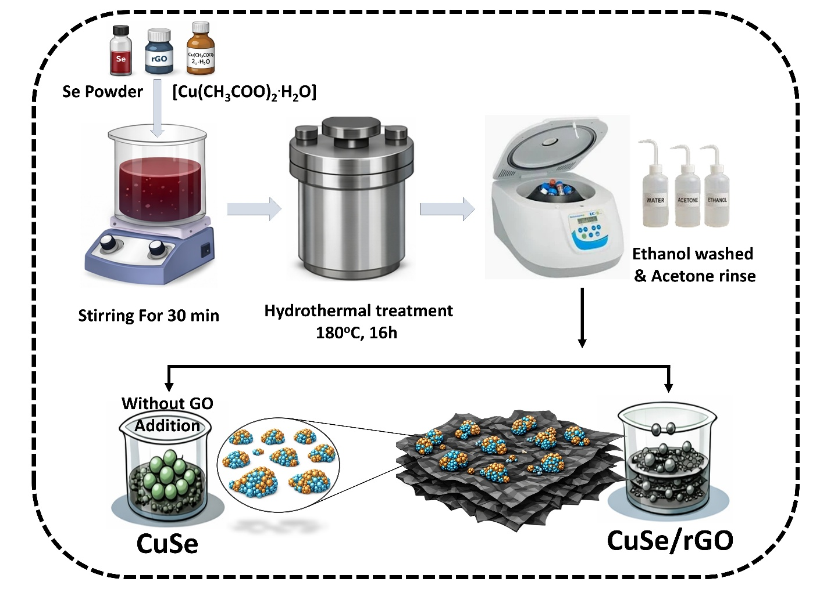
Figure 1. Synthetic scheme of preparation of CuSe/rGO composite
  - Characterization of Synthesized nanoparticles

Powder X-ray diffraction (p-XRD) analysis of pristine CuSe and the CuSe/rGO nanohybrid was utilized to investigate the phase composition, crystallinity, and structural integrity of the synthesized materials. The p-XRD pattern confirms the strong crystallinity of pristine CuSe, as shown in the figure 2(a), which indicates the presence of multiple intense and sharp diffraction peaks. The successful formation of phase-pure hexagonal CuSe without any secondary phases is demonstrated by the well-defined peak reflections corresponding to the (101), (102), (006), (106), (110), (108), (114), (1010), and (208) lattice planes, which correspond to the JCPDS database values. The characteristic diffraction peaks of CuSe are still observed in the CuSe/rGO nanohybrid, indicating that the intrinsic crystal structure of CuSe is retained after hybridization. Strong interfacial interactions between CuSe nanoparticles and the rGO sheets, as well as a reduction in crystallite size, contribute to the slight decrease in peak intensity and minor peak broadening. The characteristic graphene oxide diffraction peak at 2θ = 24–26° is absent or significantly reduced, indicating that GO has been effectively reduced and demonstrating extensive exfoliation and uniform dispersion of the composite framework.
The CuSe phase and crystallinity remain unchanged after rGO incorporation, demonstrating structural compatibility between the two components. Overall, the p-XRD results show that crystalline CuSe nanoparticles were successfully synthesized in situ and dispersed uniformly onto the rGO sheets, which is expected to enhance the structural stability and electron transport properties of the nanohybrid.
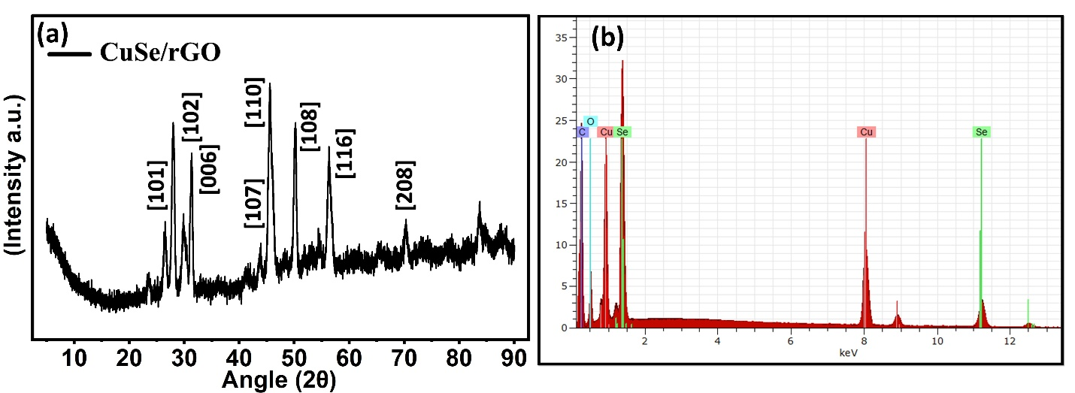
Figure 2. (a) p-XRD stacked spectra of CuSe/rGO. (b) EDS analysis of CuSe/rGO

The synthesized nanocomposite exhibited successful formation and elemental composition, as verified through Energy-Dispersive X-ray Spectroscopy (EDS/EDX) analysis of CuSe/rGO. The obtained spectrum indicates the presence of four predominant elements, corresponding to the CuSe nanostructure and reduced graphene oxide (rGO) matrix as shown in figure 2(b): copper (Cu), selenium (Se), carbon (C), and oxygen (O). The EDS quantitative analysis confirms that selenium possesses the highest normalized weight percentage (45.12 wt.%) and a corresponding atomic percentage of 17.33 at.%, indicating the significant contribution of selenium in the CuSe nanophase. Copper (Cu), selenium (Se), carbon (C), and oxygen (O), indicating the elemental composition of CuSe nanoparticles and conductive reduced graphene oxide (rGO) framework, were detected as the main elements observed in the spectrum. The compositional study confirms that selenium plays a major role in the CuSe phase, exhibiting the maximum normalized weight percentage (45.12 wt.%) and atomic composition (17.33 at.%). Oxygen content (11.06 wt.% and 20.96 at.%) may originate from residual oxygen-containing functional groups remaining on the partially reduced graphene oxide surface, adsorbed oxygen species on the material surface, or weak surface oxidation occurring during synthesis and handling processes. The EDS results indicate that copper shows an elemental composition of 23.88 wt.% with an atomic abundance of 11.39 at.%, highlighting the successful formation of copper into the copper selenide framework. The high atomic percentage of 50.32 at.% is attributed to the graphene-based carbonaceous framework of rGO, along with the presence of carbon with 19.94 weight percent, confirming the successful incorporation of reduced graphene oxide into the nanocomposite matrix. The detected oxygen contribution (11.06 wt.% and 20.96 at.%) may be attributed to adsorbed oxygen species on the surface, residual oxygen-containing functional groups on partially reduced graphene oxide and mild oxidation effect during synthesis process and handling process.
The low error value observed for Cu (1.9%), Se (4.0%), C (7.0%), and O (4.6%) shows that the acceptable accuracy and dependable nature of compositional analysis. Collectively, the EDS characterization demonstrates successful synthesis of the CuSe/rGO nanocomposite and indicates its potential in catalytic and sensing applications by confirming the coexistence and uniform anchoring of CuSe nanoparticles on the rGO matrix.

  - Morphological analysis of Synthesized nanoparticles

The morphological and microstructural properties of bare CuSe and the CuSe/rGO nanohybrid were characterized using FE-SEM and TEM analyses, as shown in Fig. The FE-SEM micrograph of bare CuSe (Fig. 3) illustrates unevenly shaped nanoparticles with rough, compact surfaces and significant agglomeration, suggesting uncontrolled nucleation and particle growth during hydrothermal synthesis. Catalytically active sites might become less available and consequently exhibit a reduced effective surface area as a result of aggregation. In contrast, the CuSe nanoparticles are evenly dispersed across the matrix, the folded and wrinkled rGO sheets in the FE-SEM image of the CuSe/rGO nanohybrid, suggesting that rGO serves as an effective support matrix that suppresses particle aggregation and encourages homogenous dispersion. The interconnected rGO network provides structural stability as well as a porous structure that improve mass transfer. These observations are further confirmed by TEM analysis. The corresponding SAED pattern (inset) demonstrates concentric diffraction rings, indicating the polycrystalline nature of CuSe, whereas the TEM picture of pristine CuSe (Fig. 3b) confirms the presence of densely packed nanoparticles with partial aggregation and strong interparticle interactions. TEM micrographs of the CuSe/rGO nanohybrid demonstrate the intimate interfacial contact between uniformly dispersed CuSe nanoparticles and thin, partially transparent rGO nanosheets. The SAED pattern (inset) confirms that the crystallinity of CuSe is maintained following hybridization. CuSe nanoparticles were successfully synthesized in situ and adsorbed on rGO, as evidenced by the combined FE-SEM and TEM analysis. This underscores the effectiveness of rGO in ensuring homogeneous dispersion and enhanced structural stability in the nanohybrid.[24]
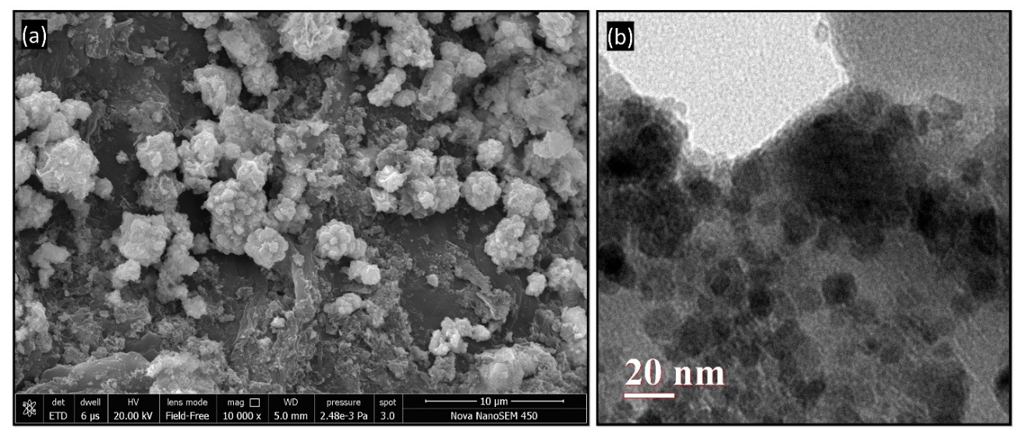
Figure 3. FE-SEM analysis of (a) CuSe/rGO. TEM analysis of (b) CuSe/rGO.
  - Peroxidase-Like Activity of CuSe/rGO
The peroxidase-like activity of CuSe/rGO nanohybrid was systematically examined and comparatively analyzed with that of pristine CuSe nanoparticles with o-phenylenediamine (OPD) as the chromogenic substrate in the presence of H₂O₂.[21] The catalytic oxidation of OPD was monitored using UV–visible spectroscopy; the formation of oxidized OPD (Ox-OPD) was confirmed by a distinct absorbance peak at 450 nm, and the inset figure shows the oxidation of OPD. The time-dependent increase in absorbance at 450 nm and the rapid emergence of CuSe/rGO and bare CuSe demonstrated blue coloration of the nanohybrid, showing excellent catalytic activity of CuSe/rGO as compared to bare CuSe nanohybrid. The absorbance profile, which approaches saturation in approximately 15 minutes, demonstrates fast reaction kinetics and excellent catalytic activity.[25] Significantly surpassing bare CuSe, the CuSe/rGO/OPD/H₂O₂ system demonstrated the highest absorbance intensity and fastest reaction rate. The strong synergistic relationship between CuSe nanoparticles and the rGO matrix, where rGO enhances faster electron transfer, prevents nanoparticle aggregation, and enables increased exposure of active catalytic sites, is responsible for this enhanced performance. As a result, enhanced OPD oxidation is promoted by the rapid breakdown of H₂O₂ and the effective production of reactive species. As demonstrated by the significant rise in absorbance, the CuSe/rGO nanohybrid exhibits remarkable nanozyme activity, successfully mimicking the catalytic activity of natural horseradish peroxidase (HRP). The observation of charge-transfer complexes during single-electron oxidation of OPD to its oxidized form (Ox-OPD) is what causes the observable color shift from colorless to blue.[26]

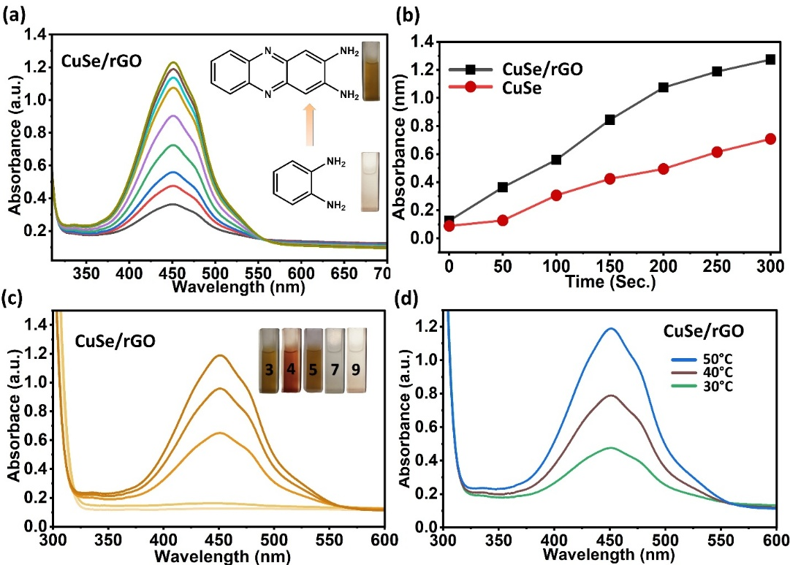
Figure 4. (a) UV-vis. spectra of oxidation of OPD in the presence of H₂O₂ catalyzed by CuSe/rGO, and the inset reaction scheme shows the oxidation of OPD with a photograph of the cuvette (colorless converted into the yellow color; oxidized product). (b) Comparative catalytic activity of of CuSe/rGO and bare CuSe, confirming enhanced catalytic efficiency of the CuSe/rGO nanohybrid. (c) pH-dependent absorbance (d) Temperature-dependent UV-Vis. Spectrum indicating enhanced catalytic activity at higher temperature
UV–visible spectroscopic analysis in Figure 4 illustrates the catalytic oxidation behavior and peroxidase-like activity of CuSe/rGO in the oxidation of o-phenylenediamine (OPD) with H₂O₂ under different conditions. The conversion of OPD into the oxidized product, 2,3-diaminophenazine (DAP), is demonstrated in Figure 4(a) by the gradual increase in absorbance intensity with ongoing reaction progress, particularly around ~450 nm. The transformation in the reaction solution from colorless to yellow is further validated by the inset reaction scheme and cuvette images, reflecting the excellent peroxidase-mimicking behavior of CuSe/rGO nanohybrid. CuSe nanoparticles and the electrically conductive reduced graphene oxide (rGO) structure operate in synergistically to enhance efficient electron mobility and catalytic efficiency, as demonstrated by the increase in absorbance intensity.
The comparative analysis of the catalytic behavior of CuSe/rGO and bare copper selenide is shown in Figure 4(b). The CuSe/rGO composite shows significantly higher absorbance values and enhanced catalytic activity during the entire reaction process, highlighting the enhances catalytic efficiency of the nanohybrid. The large surface area, enhanced electrical conductivity, and efficient charge-transfer properties of the rGO matrix, which enables effective H₂O₂ degradation and efficient OPD oxidation, are responsible for the enhanced activity. Furthermore, Figure 4(c) shows pH-dependent catalytic activity of the CuSe/rGO nanohybrid, where the absorbance intensity changes significantly under different pH conditions, suggesting that the catalytic oxidation process strongly depends on the reaction medium, While the inset image shows corresponding color change at various pH levels, the maximum absorbance observed under acidic conditions suggests elevated the formation of enhanced reactive oxygen species and improved catalytic oxidation efficiency at lower pH values. Additionally, the temperature-dependent UV-Vis spectra obtained under different conditions (30°C, 40°C, and 50°C) are further illustrated in Figure 4(d), which shows a gradual increase in absorbance intensity with higher temperature. Elevated temperatures enhance molecular collision frequency, improve electron-transfer kinetics, and enhance catalytic oxidation efficiency, as indicated by the maximum absorbance recorded at 50°C. Overall, these findings indicate that the synergistic effects of CuSe nanoparticles and the conductive rGO framework imparts exceptional catalytic, optical, and colorimetric sensing properties of CuSe/rGO nanohybrid.
  - Effect of Radical Trapping
Tert-butyl alcohol (TBA) and benzoquinone (BQ) were utilized as selective scavengers in a free radical scavenging assay to more precisely identify the specific free radical species contributing to the peroxidase-like activity of the CuSe/rGO nanohybrid. Whereas benzoquinone selectively scavenges superoxide radicals (O₂^{-●}), tert-butyl alcohol is recognized to efficiently inhibit hydroxyl radicals (●OH). The absorbance spectra were significantly reduced in the presence of TBA than in BQ, as shown in Figure 5. These results indicate that ●OH radicals dominate the catalytic activity while O₂^{-●} radicals exert a smaller effect. These results confirm that both hydroxyl mediates the peroxidase-mimicking activity (●OH) and superoxide radicals (O₂●); however, the catalytic activity is mostly driven by the production of ●OH.
The cooperative interaction between the CuSe nanoparticles and the rGO support is responsible for the increased radical production and catalytic activity of CuSe/rGO. While rGO offers a high surface area platform that guarantees uniform nanoparticle dispersion, reveals extra active Cu-based sites, and promotes effective electron transport, CuSe exhibits multiple oxidation states (Cu¹⁺/Cu²⁺), which facilitates single-electron transfer processes.
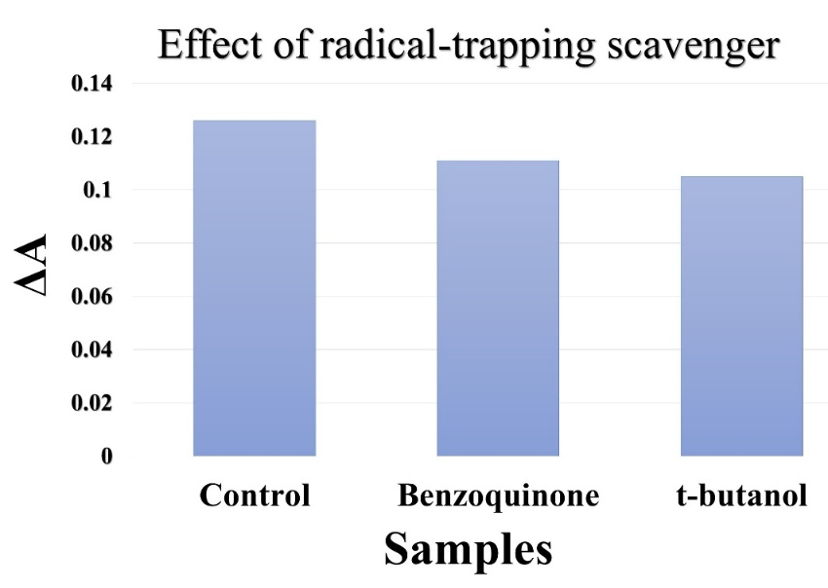
Figure 5. Effect of radical-trapping scavengers

Once introduced, H₂O₂ molecules attach onto the surface of the CuSe/rGO nanohybrid and are subsequently activated to produce ●OH and O₂⁻● radicals. As observed in previous transition metal and rGO-based nanozyme systems, these radicals are stabilized through partial electron delocalization with the nanohybrid. Chromogenic substrate OPD is subsequently oxidized by the generated radicals, resulting in the respective oxidized products along with a discernible color shift. Collectively, these findings demonstrate that the superior catalytic performance of CuSe/rGO nanohybrid results from the combined effects of radical generation, stabilization via electron transfer, and improved electron transfer enabled by rGO, demonstrating its suitability as a nanozyme for sensing applications.[27], [28], [29]
- Conclusion
In conclusion, a one-pot hydrothermal approach was successfully utilized to synthesize the graphene-supported copper selenide (CuSe/rGO) nanohybrid, which resulted in a uniform dispersion of CuSe nanoparticles on the rGO surface and efficient inhibition of nanoparticle aggregation. Enhanced interfacial interaction, which plays a role in improved electron transport and catalytic efficiency, was confirmed by structural and morphological analyses. The enhanced oxidation of OPD as substrates in the presence of H₂O₂ demonstrates that the CuSe/rGO nanohybrid exhibited significantly higher peroxidase-like activity than pristine CuSe.
Mechanistic studies demonstrated that hydroxyl radicals (•OH) are the key reactive species involved in causing substrate oxidation, and that the nanohybrid synergistic interactions within the nanohybrid system and rapid charge transfer significantly increase the formation of reactive radicals.
In summary, the CuSe/rGO nanohybrid is a reliable, efficient, and cost-effective nanozyme platform with significant potential for use in environmental monitoring, biosensing, and biomedical analysis. Its suitability as a next-generation nanozyme platform for selective biomolecule detection is further validated by the integration of experimental observations with computational insights.
Declaration of Competing Interest: There are no conflicts to declare.
Data availability. Data is available based upon appropriate request.
Author Contribution: The manuscript has been written through the contributions of all authors. All authors have approved the final version of the manuscript.
References
[1] T. L. Doane and C. Burda, “The unique role of nanoparticles in nanomedicine: imaging, drug delivery and therapy,” Chem. Soc. Rev., vol. 41, no. 7, p. 2885, 2012, doi: 10.1039/c2cs15260f.
[2] K. Mitra, A. B. Ghosh, A. Sarkar, N. Saha, and A. K. Dutta, “Colorimetric estimation of human glucose level using γ-Fe2O3 nanoparticles: An easily recoverable effective mimic peroxidase,” Biochemical and Biophysical Research Communications, vol. 451, no. 1, pp. 30–35, Aug. 2014, doi: 10.1016/j.bbrc.2014.07.028.
[3] H. Wei and E. Wang, “Fe₃ O₄ Magnetic Nanoparticles as Peroxidase Mimetics and Their Applications in H₂ O₂ and Glucose Detection,” Anal. Chem., vol. 80, no. 6, pp. 2250–2254, Mar. 2008, doi: 10.1021/ac702203f.
[4] M. Bilal et al., “Enzyme mimic nanomaterials as nanozymes with catalytic attributes,” Colloids and Surfaces B: Biointerfaces, vol. 221, p. 112950, Jan. 2023, doi: 10.1016/j.colsurfb.2022.112950.
[5] K. Kim, K. N. Chaudhari, S. Kim, Y. Kim, and K. S. Shin, “Facile single-step synthesis of Cu-rGO nanocomposite through simultaneous reduction process and its peroxidase mimic activity,” Journal of Industrial and Engineering Chemistry, vol. 95, pp. 388–396, Mar. 2021, doi: 10.1016/j.jiec.2021.01.013.
[6] T. Akaike et al., “Cysteinyl-tRNA synthetase governs cysteine polysulfidation and mitochondrial bioenergetics,” Nat Commun, vol. 8, no. 1, p. 1177, Oct. 2017, doi: 10.1038/s41467-017-01311-y.
[7] Y. Hou et al., “Sulfide regulation and catabolism in health and disease,” Sig Transduct Target Ther, vol. 10, no. 1, p. 174, May 2025, doi: 10.1038/s41392-025-02231-w.
[8] H. Zhao et al., “Platinum Palladium Bimetallic Nanozymes Stabilized with Vancomycin for the Sensitive Colorimetric Determination of L-cysteine,” Biomolecules, vol. 13, no. 8, p. 1254, Aug. 2023, doi: 10.3390/biom13081254.
[9] Y. Zhang et al., “Recent advances in MOF-based nanozymes: Synthesis, activities, and bioapplications,” Biosensors and Bioelectronics, vol. 263, p. 116593, Nov. 2024, doi: 10.1016/j.bios.2024.116593.
[10] C. Zhang and Z. Nan, “Improvement of Fe_{0.8} Ni_{0.2} S₂ Peroxidase-like Activity through the Accelerated Conversion from Fe³⁺ to Fe²⁺,” J. Phys. Chem. C, vol. 126, no. 9, pp. 4355–4364, Mar. 2022, doi: 10.1021/acs.jpcc.1c10325.
[11] O. Adeniyi, S. Sicwetsha, and P. Mashazi, “Nanomagnet-Silica Nanoparticles Decorated with Au@Pd for Enhanced Peroxidase-Like Activity and Colorimetric Glucose Sensing,” ACS Appl. Mater. Interfaces, vol. 12, no. 2, pp. 1973–1987, Jan. 2020, doi: 10.1021/acsami.9b15123.
[12] X. Chen, B. Su, Z. Cai, X. Chen, and M. Oyama, “PtPd nanodendrites supported on graphene nanosheets: A peroxidase-like catalyst for colorimetric detection of H2O2,” Sensors and Actuators B: Chemical, vol. 201, pp. 286–292, Oct. 2014, doi: 10.1016/j.snb.2014.04.067.
[13] Y. Guo et al., “Fabrication of Ag–Cu₂ O/Reduced Graphene Oxide Nanocomposites as Surface-Enhanced Raman Scattering Substrates for in Situ Monitoring of Peroxidase-Like Catalytic Reaction and Biosensing,” ACS Appl. Mater. Interfaces, vol. 9, no. 22, pp. 19074–19081, Jun. 2017, doi: 10.1021/acsami.7b02149.
[14] S. Dutta et al., “A Gel-Based Approach To Design Hierarchical CuS Decorated Reduced Graphene Oxide Nanosheets for Enhanced Peroxidase-like Activity Leading to Colorimetric Detection of Dopamine,” J. Phys. Chem. C, vol. 119, no. 41, pp. 23790–23800, Oct. 2015, doi: 10.1021/acs.jpcc.5b08421.
[15] G. Darabdhara, B. Sharma, M. R. Das, R. Boukherroub, and S. Szunerits, “Cu-Ag bimetallic nanoparticles on reduced graphene oxide nanosheets as peroxidase mimic for glucose and ascorbic acid detection,” Sensors and Actuators B: Chemical, vol. 238, pp. 842–851, Jan. 2017, doi: 10.1016/j.snb.2016.07.106.
[16] C. Wang et al., “Copper Selenide Micro/Nanocrystals on Carbon Paper via Chemical Vapor Deposition Selenylation as Electrodes for Non-enzymatic Glucose Sensing,” ACS Appl. Nano Mater., vol. 6, no. 14, pp. 13260–13269, Jul. 2023, doi: 10.1021/acsanm.3c01967.
[17] L. A. Saona et al., “Cysteine-Mediated Green Synthesis of Copper Sulphide Nanoparticles: Biocompatibility Studies and Characterization as Counter Electrodes,” Nanomaterials, vol. 12, no. 18, p. 3194, Sep. 2022, doi: 10.3390/nano12183194.
[18] S. Kavitha, S. Mary Jelastin Kala, A. Anand Babu Christus, and A. Ravikumar, “Colorimetric determination of cysteine and copper based on the peroxidase-like activity of Prussian blue nanocubes,” RSC Adv., vol. 11, no. 59, pp. 37162–37170, 2021, doi: 10.1039/D1RA06838E.
[19] F. Yang, M. Mu, and K. Zhang, “Ultralong NiSe nanowire anchored on graphene nanosheets for enhanced electrocatalytic performance of triiodide reduction,” RSC Adv., vol. 11, no. 44, pp. 27681–27688, 2021, doi: 10.1039/D1RA04367F.
[20] M. Imran et al., “Silver and carbon nitride-doped nickel selenide for effective dye decolorization and bactericidal activity: in silico docking study,” RSC Adv., vol. 14, no. 28, pp. 20004–20019, 2024, doi: 10.1039/D4RA01437E.
[21] N. Chauhan, N. Sharma, S. Buhari, P. P. Das, S. Kumar, and A. Chalana, “Facile Synthesis of Copper Telluride Nanoparticles as a Robust Nanoenzymatic Catalyst for Intrinsic Peroxidase‐Like Activity,” ChemistrySelect, vol. 9, no. 14, p. e202304361, Apr. 2024, doi: 10.1002/slct.202304361.
[22] J. Guan, J. Peng, and X. Jin, “Synthesis of copper sulfide nanorods as peroxidase mimics for the colorimetric detection of hydrogen peroxide,” Anal. Methods, vol. 7, no. 13, pp. 5454–5461, 2015, doi: 10.1039/C5AY00895F.
[23] Z. Shan et al., “Chloride accelerated Fenton chemistry for the ultrasensitive and selective colorimetric detection of copper,” Chem. Commun., vol. 52, no. 10, pp. 2087–2090, 2016, doi: 10.1039/C5CC07446K.
[24] S. Khaladkar et al., “Interface Engineering of Nickel Selenide and Graphene Nanocomposite for Hybrid Supercapacitor,” Adv Energy and Sustain Res, vol. 4, no. 7, p. 2300013, Jul. 2023, doi: 10.1002/aesr.202300013.
[25] J. Dong, L. Zhang, W. Li, X. Hu, A. Chen, and C. Li, “Hydrangea-like AuPtRu/ZnO-rGO Nanocomposites with Enhanced Peroxidase Mimiking Activity for Senitive Colorimetric Determination of H₂ O₂,” ACS Omega, vol. 8, no. 51, pp. 49218–49227, Dec. 2023, doi: 10.1021/acsomega.3c07499.
[26] P. Das, P. Borthakur, P. K. Boruah, and M. R. Das, “Peroxidase Mimic Activity of Au–Ag/ l -Cys-rGO Nanozyme toward Detection of Cr(VI) Ion in Water: Role of 3,3′,5,5′-Tetramethylbenzidine Adsorption,” J. Chem. Eng. Data, vol. 64, no. 11, pp. 4977–4990, Nov. 2019, doi: 10.1021/acs.jced.9b00819.
[27] L. Su, J. Feng, X. Zhou, C. Ren, H. Li, and X. Chen, “Colorimetric Detection of Urine Glucose Based ZnFe₂ O₄ Magnetic Nanoparticles,” Anal. Chem., vol. 84, no. 13, pp. 5753–5758, Jul. 2012, doi: 10.1021/ac300939z.
[28] W. Shi, X. Zhang, S. He, and Y. Huang, “CoFe2O4 magnetic nanoparticles as a peroxidase mimic mediated chemiluminescence for hydrogen peroxide and glucose,” Chem. Commun., vol. 47, no. 38, p. 10785, 2011, doi: 10.1039/c1cc14300j.
[29] N. Wang, L. Zhu, D. Wang, M. Wang, Z. Lin, and H. Tang, “Sono-assisted preparation of highly-efficient peroxidase-like Fe3O4 magnetic nanoparticles for catalytic removal of organic pollutants with H2O2,” Ultrasonics Sonochemistry, vol. 17, no. 3, pp. 526–533, Mar. 2010, doi: 10.1016/j.ultsonch.2009.11.001.

Graphical Abstract
