Ultrasound-Assisted DLLME Coupled with TLC Imaging for Rapid Determination of Risperidone in Biological Samples
Abstract:
Risperidone (RSP) is an antipsychotic drug widely prescribed for patients suffering from depression or other psychotic episodes. However, its misuse or overdose has been implicated in accidental and suicidal fatalities, underscoring the need for sensitive and reliable analytical methodologies for its determination in biological samples. In the present study, the ultrasonic-assisted dispersive liquid–liquid microextraction (UA-DLLME) technique, coupled with thin-layer chromatography (TLC) and a smartphone-based digital image colorimetry analytical method, was developed, optimized, validated, and applied for the determination of RSP in blood, urine, and pharmaceutical samples. Among the tested conditions, trichloroethylene (100 µL) and acetonitrile (800 µL) were found to be the most suitable extraction and dispersing solvents, respectively, at a pH of 10, with 1 minute of ultrasonication yielding the maximum extraction efficiency. An ethyl acetate:methanol:ammonia solution (85:10:5 v/v/v) was used as the mobile phase to achieve TLC separation. Calibration curves exhibited linearity in the concentration range of 0.25–10 mg/mL with limits of detection (LOD) of 0.18, 0.22, and 0.03 mg/mL and limits of quantification (LOQ) of 1.00, 0.08, and 0.46 mg/mL for blood, urine, and tablet samples, respectively. The accuracy and precision (intraday and interday) were also calculated according to SWGTOX guidelines. The recovery for the method was 165.03%, 81.88%, and 98.34% for blood, urine, and pharmaceutical tablet samples, respectively. In the next step, greenness of the method was identified using the complex Green Analytical Procedure Index (GAPI) and the Analytical Greenness (AGREE) calculators, and Environmental, Performance, and Practicality Index (EPPI), confirming its environmental sustainability. Developed an analytical method for UA-DLLME–TLC–smartphone colorimetry provides a rapid, cost-effective, environmentally sustainable strategy for the determination of risperidone in biological samples, with substantial applicability in forensic toxicology for the identification and quantification in suspected overdose or poisoning cases.
Keywords: Dispersive Liquid-Liquid Microextraction, Thin-layer chromatography image analysis, Green analytical chemistry, complex GAPI, AGREE, EPPI, microextraction.

- Introduction
Risperidone (RSP) is an anti-psychotic drug (Belova et al., 2020; Elman, 2002) primarily used to treat people suffering from psychotic episodes due to schizophrenia, bipolar disorder, and depression (Dedania et al., 2011; Yousefsani et al., 2022). It works by helping restore the balance of dopamine and serotonin in our brain, thus reducing symptoms like delusions, hallucinations, mood swings, and aggressive behaviour (Dedania et al., 2011). Generally, risperidone is a prescription drug available in tablets, liquid, and injectable form (Patel et al., 2010). RSP works by blocking the dopamine D2 receptor and serotonin 5-HT2A receptor in the brain (Belova et al., 2020; Dedania et al., 2011; Patel et al., 2010). Inhibiting the dopamine receptor RSP reduces the psychotic symptoms, such as hallucinations and delusions (Dedania et al., 2011; Elman, 2002). Blocking the serotonin receptor it contributes to mood-stabilizing effects and helps improve negative symptoms and cognitive function (Dedania et al., 2011; Elman, 2002). Common side effects of RSP include drowsiness, dizziness, weight gain, increased appetite, and dry mouth. In some patients, it can cause extrapyramidal symptoms such as tremors or stiffness (Patel et al., 2010). Generally, RSP is safe if taken as prescribed, but an overdose can be serious and potentially fatal (Belova et al., 2020; Yu et al., 2020), which may include severe sedation, hypotension, tachycardia, respiratory depression, coma, and death. The risk of deadly outcomes increases with very high doses or when RSP is combined with other CNS depressants like alcohol or benzodiazepines (Belova et al., 2020). Fatality due to RSP overdosing is low but has been reported, often linked to intentional self-poisoning or accidental ingestion in vulnerable people (Belova et al., 2020).

In earlier times, drug extraction was performed using liquid-liquid extraction (LLE) and solid-phase extraction (SPE), which are traditional methods with many disadvantages, such as time-consuming, non-environment-friendly, expensive, and laborious handling (He et al., 2019; Patel et al., 2010). Thus, the introduction of an advanced extraction technique, dispersive liquid-liquid microextraction (DLLME) by Rezaee et al. in 2006, brought about a revolutionary change in separation science (Jain, 2018; Jain et al., 2020, 2021). DLLME is a much faster and more effective extraction method, enabling the extraction of analytes in trace amounts (Jain, 2018; Jain et al., 2020, 2021). In which the disperser solvent acts as a third phase, dispersing the organic solvent into the aqueous phase via micelle formation, thereby increasing the surface area for the mass transfer of the analyte into the organic solvent (Jain, 2018; Jain et al., 2020, 2021). After centrifugation, the organic solvent enriched with the analyte separates from the aqueous phase and can be collected for analysis by techniques such as chromatography or spectroscopy (Jain, 2018; Jain et al., 2020, 2021). DLLME is valued for its simplicity, speed, low solvent consumption, and high enrichment factors, making it widely used in environmental, pharmaceutical, and forensic analysis.

Thin-layer chromatography (TLC) has been a staple technique in analytical chemistry due to its simplicity, speed, and versatility (Jain et al., 2017); Akash et al., 2025). Since 2006, TLC has evolved from a rudimentary method for separating compounds into a highly refined tool widely used in fields ranging from environmental to forensic science (Jain et al., 2017); Siegel, 2015) . TLC remains invaluable for preliminary qualitative analysis, monitoring reaction progress, and purity assessment. Its cost-effectiveness and minimal solvent use make it a preferred choice in resource-limited settings (Akash et al., 2025; Siegel, 2015). To upscale the technique, we have combined TLC with image analysis using the ImageJ software to make it a detection technique (Jain et al., 2017); (Jain, 2018; Jain et al., 2020, 2021). Traditional TLC detection often relies on visual inspection or densitometry, which can be subjective and limited in precision. ImageJ offers a way to digitize TLC plates through high-resolution scanning or photography, enabling objective, reproducible analysis of spot intensities and areas (Jain et al., 2017); (Jain, 2018; Jain et al., 2020, 2021). This digital approach enhances sensitivity and allows quantification of compounds even at low concentrations (Jain et al., 2017); (Jain, 2018; Jain et al., 2020, 2021). Researchers have demonstrated that, with proper calibration and image processing, ImageJ can accurately measure spot intensity and size, with results that correlate well with compound concentration (Jain et al., 2017); (Jain, 2018; Jain et al., 2020, 2021). This capability transforms TLC from a primarily qualitative method into a semi-quantitative or quantitative tool.

This study couples UA-DLLME with TLC image analysis to optimize, validate, apply, and compare the developed methodology for the detection of RSP in real samples (Blood, urine, and pills) with High Performance Liquid Chromatography (HPLC). Along with this, the greenness of the developed method is evaluated using the Green Analytical Procedure Index (GAPI) (Plotka-Wasylka, 2018), Analytical Greenness (AGREE) (Pena-Pereira et al., 2020), and Environmental, Performance, and Practicality Index (EPPI) (Elagamy et al., 2025) calculators.

- Experimental
  - Reagents and chemicals
The reagents and chemicals used in this study were of analytical grade unless stated otherwise. The standard sample of Risperidone (RSP, dissolved in methanol) was obtained from Sigma-Aldrich USA. Acetonitrile (ACN, purity >99%), acetone (ACT, purity >99%), ethanol (EtOH, purity >99%), and methanol (MeOH, purity >99%) were obtained from SRL Chemicals (Mumbai, India) and used as dispersive solvents. Chloroform (CF, purity >99%), chlorobenzene (CB, purity >99%), carbon tetrachloride (CCl₄, purity >99%), dichloromethane (DCM, purity >99%), and trichloroethylene (TCE, purity >99%) were used as extraction solvents obtained from SRL Chemicals (Mumbai, India). Pre-coated TLC aluminium plates (20 x 20 cm) with silica gel 60 F254 were obtained from Sigma-Aldrich USA. The ultrapure water for microextraction and HPLC-grade water were used in the study.

  - Sample Preparation
2.2.1 Sample collection
The samples used in this study were blood and urine (biological samples) and pharmaceutical pills (prescribed by the doctor). The biological samples (blood and urine) were donated by the authors (aged 28-40 years), and the pharmaceutical tablet (Risperidone 2 mg) was bought from a pharmacy store in Greater Noida, India. These samples were utilized to develop and validate the methodologies, and importantly, this study was conducted in accordance with the ethical guidelines of the Indian Council of Medical Research (ICMR), New Delhi. The approval obtained from the Institutional Ethics Committee (Ref No. SU/SMS&R/76-A/2023/176) serves as a testament to the ethical scrutiny that guided the research process.

2.2.2 Sample fortification and method development
Blood Sample
First, 0.5 mL of the blood sample was spiked with 15 µL of the RSP stock solution and deproteinized by mixing with 1 mL of methanol/acetonitrile. The mixture was centrifuged at 5000 rpm for 5 minutes, and the serum was transferred to another tube. For UA-DLLME TLC image analysis, 0.5 mL of the deproteinized sample was transferred to a new tube and diluted to 5 mL with ultrapure water (fig 1).
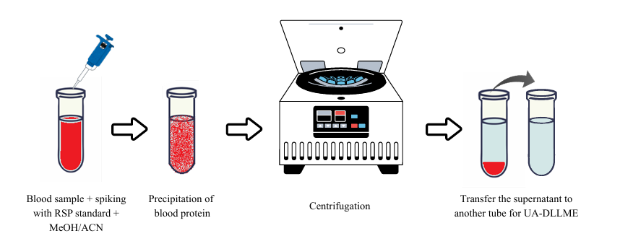
Figure 1: Purification of the blood sample.
Urine sample
0.5 mL of the urine sample was transferred into a tube and diluted to 5 mL with ultrapure water. This sample was spiked with 15 µL of the stock solution of RSP, vortexed for 3-5 minutes, and then used for UA-DLLME TLC image analysis (fig 2).

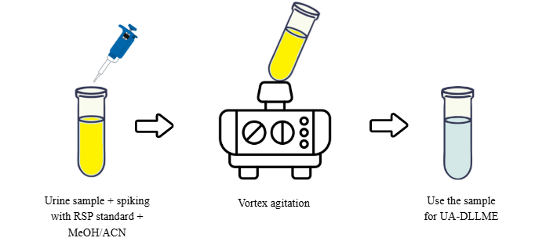
Figure 2: Purification of the urine sample.
Pill sample
Ten tablets of RSP (2 mg each) were ground into a fine powder. The amount was measured based on the weight of one tablet. Two mL of ultrapure water was used to dissolve the powder, which was then ultrasonicated for 10 minutes and centrifuged for 5 minutes. The resulting RSP solution was collected and used to fortify 5 mL of ultrapure water for UA-DLLME TLC image analysis (fig 3).

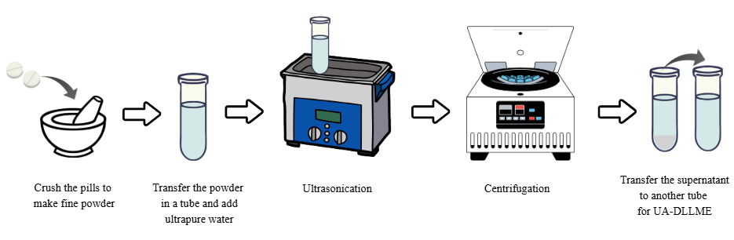
Figure 3: Purification of the pill sample.

2.2.3 Ultrasonicator-assisted Dispersive Liquid-Liquid Micro-Extraction
The purified and fortified samples of blood and urine, along with the pill sample of ultrapure water with pill solution, were used. Then the pH of these samples was adjusted by adding a few drops of hydrochloric acid/ sodium hydroxide solutions to get a pH of 10. Now, the mixture of extraction solvent (trichloroethylene, 100 µL) and disperser solvent (acetonitrile, 800 µL) was rapidly injected into the samples, and the formation of a cloudy solution was observed. Then these solvent systems were carefully centrifuged at 5000 rpm for 5 mins, and the supernatant was discarded. The sedimented phase (fig 4) obtained was approximately 80 µL, which was further analyzed using TLC image analysis.

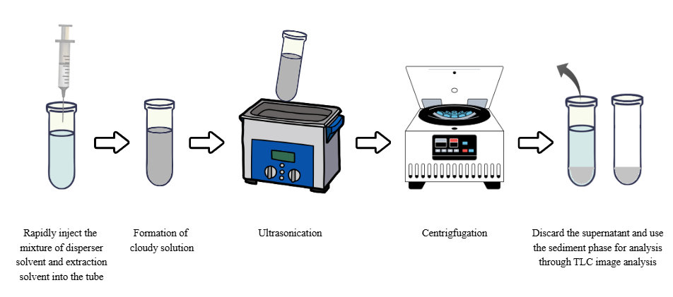
Figure 4: Ultrasonicator-assisted dispersive liquid-liquid microextraction.

2.3 Detection
2.3.1 Thin Layer Chromatography Image Analysis
From the sediment phase, 5 µL of extract from blood, urine, and pill samples was spotted on the TLC plate and air-dried for 5 mins. The pre-saturated mobile phase of ethyl acetate–methanol–ammonia solution (85:10:5 v/v/v) was prepared, and the TLC plate was placed in it. Once the plate was run to the desired markings, it was removed from the development chamber and left to air-dry for 5 minutes. The spots were visible under the UV chamber, and a clear photograph was taken with the help of a smartphone (One Plus CE 3 lite). The image was then processed by the freely available software ImageJ, by which the density of the spots was calculated and converted into densitograms (fig 5 and 6).
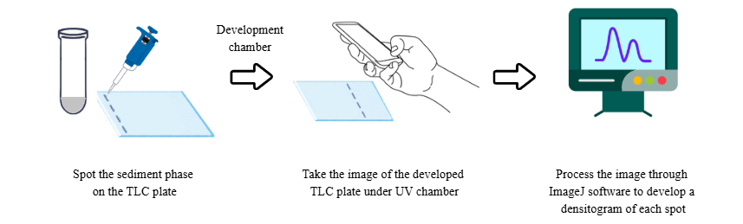
Figure 5: Thin-layer chromatography image analysis.
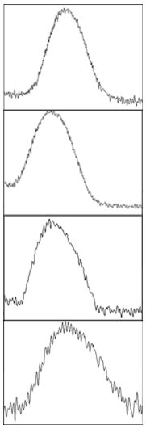
- (b) (c) (d)
Figure 6: Densitogram of RSP created by ImageJ software of (a) standard at 4 mg/ml, (b) blood sample, (c) urine sample, and (d) pill sample.

2.3.2 High-performance liquid chromatography analysis
High-Performance Liquid Chromatography (HPLC) was an instrumental technique used to determine the closeness of the results from the developed method with TLC image analysis and HPLC. The calibration curve for the plot for RSP between 50 to 100 ppm. The mobile phase was of methanol: acetonitrile (80:20 v/v), and the flow rate was maintained at 1 mL/min. The mobile phase was filtered through a 0.45 micron filter paper and ultrasonicated for 10 minutes before use. The sediment phase of blood, urine, and pill samples from the UA-DLLME was made up to 1ml by adding HPLC-grade methanol. 20 µL of each sample was injected into the column (Reverse phase, C₁₈), and the run time was standardized at 10 minutes. The separation was performed with the C₁₈ column (250 x 4.6 mm, 5 micron) at an ambient temperature. The detector used was a photodiode array detector (PDA), and the wavelength was kept between 200-400 nm (fig 7a, 7b, 7c, and 7d).

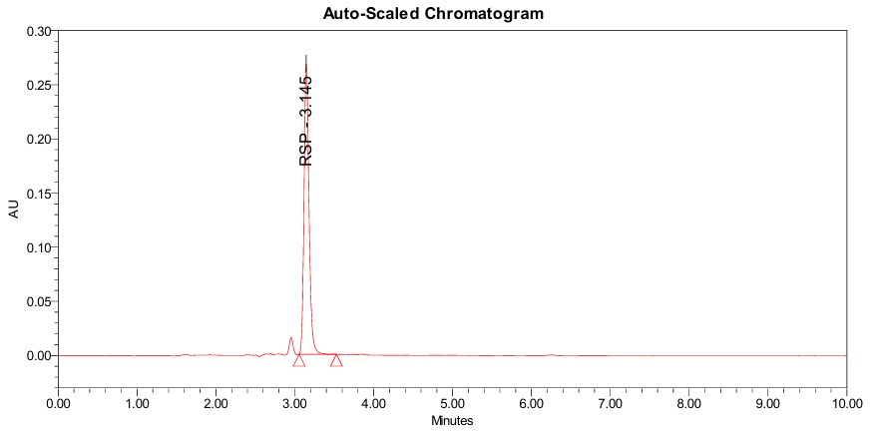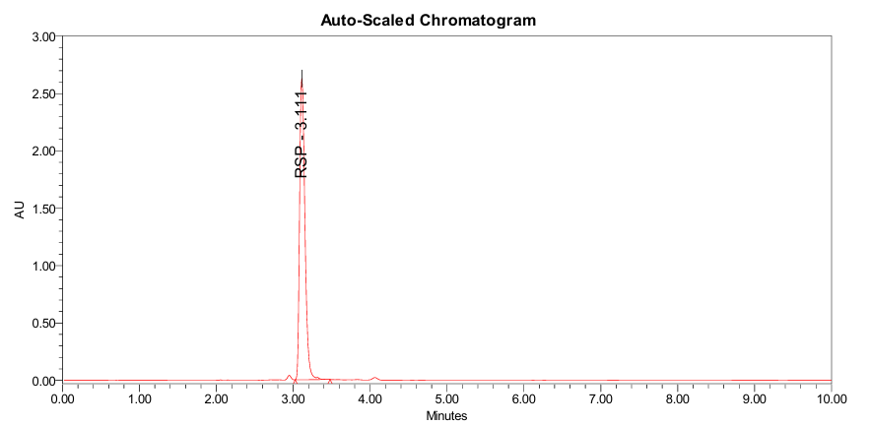
- (b)
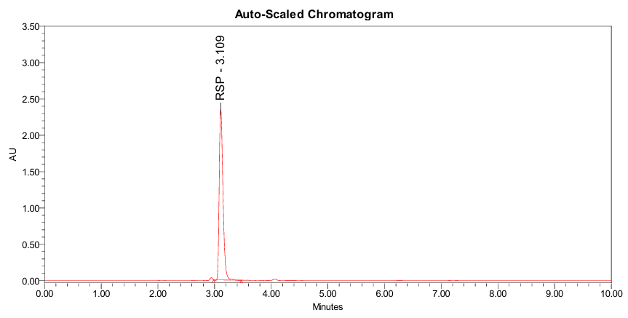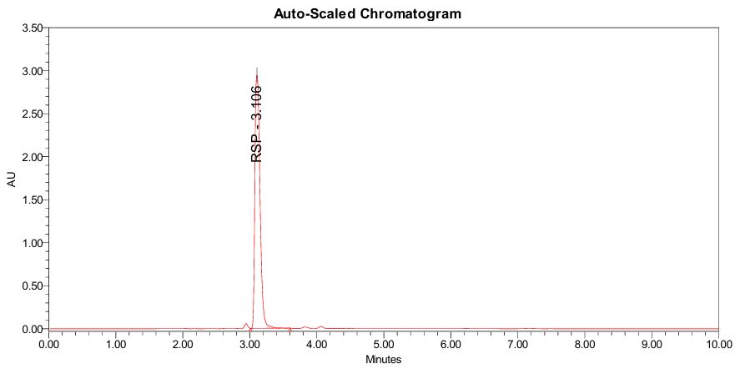
(c) (d)

Figure 7: HPLC chromatogram of RSP (a) standard at 80 ppm, (b) blood sample, (c) urine sample, and (d) pill sample.

- Results and Discussion
  - Optimization
The optimization process was performed to study the standard conditions, namely, the extraction solvent and its volume, the disperser solvent and its volume, pH, ionic strength, and extraction mode, using a single-variable-at-a-time approach to extract RSP. To choose the best solvent system for RSP chloroform–ethanol (7:3 v/v) (Belova et al., 2020), ethyl acetate–methanol–ammonia solution (85:10:5 v/v/v) (Belova et al., 2020), and butanol–acetic acid–water (12:3:5 v/v/v) (Maślanka et al., 2009) were screened. The combination of ethyl acetate–methanol–ammonia solution (85:10:5 v/v/v) showed the best separation of RSP. Also, the saturation time was altered between the ranges of 15 to 30 minutes, which is important for selecting the solvent system. The saturation time for 15 minutes was finalized as it provides the best yield. The solvent system ethyl acetate–methanol–ammonia solution (85:10:5 v/v/v) with a 15 minutes saturation time was selected (fig 8).

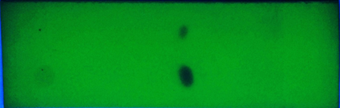
Figure 8: Screening of mobile phase for RSP at concentration 4 mg/ml and 10 mg/ml.

The requirement for the extraction solvent to be used for DLLME is that it should be denser than water, hence, trichloroethylene (TCE) (d = 1.46), chlorobenzene (CB) (d = 1.11), carbon tetrachloride (CCl₄) (d = 1.59), chloroform (CF) (d = 1.48), and dichloromethane (DCM) (d = 1.32) were taken. To select the most suitable extraction solvent, a series of experiments was performed, where 100 µL of each extraction solvent and a fixed volume (500 µL) of disperser solvent ethanol (EtOH) were mixed. These mixtures were rapidly injected into the aqueous solution spiked with 15 µL of RSP stock solution with neutral pH, forming a cloudy solution. The entire UA-DLLME-TLC image analysis was performed in the same manner as above. Figure 9a shows that trichloroethylene (TCE) displayed the highest extraction efficiency for RSP. Similarly, to determine the better volume of TCE for the higher extraction yield, different volumes 75-125 µL of TCE were added with a fixed volume (500 µL) of EtOH. This mixture was used to perform the UA-DLLME-TLC image analysis, where TCE at the volume of 100 µL gave the best results (fig 9b).

Once the extraction solvent and its volume were determined, the next step was to optimize the disperser solvent and its volume. Here, favorable results could be achieved with the solvent being more dispersible in an aqueous medium, increasing the surface area for the analyte to be extracted. The four favorable disperser solvents for RSP were methanol (MeOH), ethanol (EtOH), acetonitrile (ACN), and acetone (ACT), which were selected. Optimized extraction solvent (TCE) and its volume (100 µL) were added to 500 µL of all four disperser solvents, and UA-DLLME-TLC image analysis was performed. Figure 10a shows that acetonitrile (ACN) showed better extraction of RSP. Then, to determine the different volumes of ACN, ranging between 200-1000 µL of disperser solvent was added with an optimized volume of 100 µL of extraction solvent. Keeping the pH neutral, the process of UA-DLLME-TLC image analysis was performed, which displayed that the ACN at 800 µL volume gave the best results of extraction for RSP (fig 10b).

An organic solvent must be in molecular form for better extraction, which can be determined by its pKa value. Therefore, according to the Henderson-Hasselbalch equation, acidic drugs can be fully ionized (99%) two units above their pKa value or have no ionization (1%) two units below their pK_{a} value. Since the pK_{a} value for RSP is 8.3, the pH was optimized between pH 7 and pH 11. 0.1 M solution of hydrochloric acid/ sodium hydroxide was freshly prepared and used to maintain the respective pH of the sample solutions, keeping the optimized parameters intact. Once the pH was maintained, the sample solutions underwent the process of UA-DLLME-TLC image analysis. Figure 11a shows that the highest extraction efficiency was obtained when the pH was maintained at pH 10.

The extraction efficiency of DLLME increases with the addition of salt, which inhibits the dissolution of the targeted analyte in the sample solution. Therefore, 0-10% (w/v) of sodium chloride was prepared in HPLC-grade water to study the effect of ionic strength on the sample solution. The optimized parameters were kept as is, and the UA-DLLME-TLC image analysis was performed. This depicted that the addition of salt did not possess any relevant impact on the extraction efficiency of the RSP (fig 11b).

Lastly, the time interval for the extraction mode (ultrasonicator) was optimized for 1 – 5 mins. The ultrasonication was performed to emulsify the tiny droplets formed by the rapid encounter of the extraction and disperser solvents on the sample solution. Thus, increasing the surface area for the target analyte to be extracted. The entire process of UA-DLLME-TLC image analysis was performed using the optimized parameters. Figure 12 shows that the response of RSP was maximum at 1 minute.

Figure 9: (a)Screening of the extraction solvent and (b) the extraction solvent volume

Figure 10: (a) Screening of the disperser solvent and (b) the disperser solvent volume

Figure 11: (a) Screening of pH and (b) the ionic strength.

Figure 12: Screening of the extraction mode (ultrasonicator) time.

3.2 Method validation
The optimized parameters were kept intact for the method validation according to ‘The Standard Practice for Method Validation in Forensic Toxicology by the Scientific Working Group of Forensic Toxicology (SWGTOX)’ for the suggested UA-DLLME-TLC image analysis methodology for the detection of RSP. The target analyte (i.e., RSP) was fortified at various concentrations ranging between 0.25 and 10 mg/mL. The limit of detection (LOD) and limit of quantification (LOQ) (table 1) of the method were found to be 0.18 and 1.00 for blood, 0.22 and 0.08 for urine, and 0.03 and 0.46 for the pill samples. The calibration curve (fig 13a, 13b, and 13c) was plotted in the concentration range between 1-8 mg/ml in blood, urine, and pill samples. Additionally, the accuracy, precision (intraday and interday), and recovery of the method were also calculated as given in the table 1.

Table 1: Validation of the developed methodology for RSP in blood, urine, and pill samples.

Sample | LOD |  | LOQ |  | Linearity | R² value | Conc. (mg/ml) | Precision |  | Accuracy | Relative recovery
 |  |  |  |  |  |  |  | Intraday | Interday | Accuracy | Relative recovery
Blood | 0.5 mg/ml | 0.18 | 1 mg/ml | 1.00 | y = 2233.3x | 0.995 | 2 | 4.34 | 7.87 | 95.96 | 165.03
 |  |  |  |  |  |  | 6 | 2.38 | 4.91 | 97.93 | 165.03
 |  |  |  |  |  |  | 10 | 2.07 | 5.63 | 97.55 | 165.03
Urine | 1 mg/ml | 0.22 | 2 mg/ml | 0.08 | y = 4643.5x | 0.993 | 1 | 8.07 | 1.11 | 94.95 | 81.88
 |  |  |  |  |  |  | 6 | 3.27 | 6.5 | 96.19 | 81.88
 |  |  |  |  |  |  | 10 | 1.3 | 5.27 | 98.48 | 81.88
Pill | 1 mg/ml | 0.03 | 2 mg/ml | 0.46 | y = 2434.7x | 0.992 | 2 | 1.24 | 2.97 | 95.63 | 98.34
 |  |  |  |  |  |  | 6 | 3.63 | 2.64 | 98.64 | 98.34
 |  |  |  |  |  |  | 10 | 0.63 | 6.97 | 99.29 | 98.34

Figure 13: Calibration curve (a) blood, (b) urine, and (c) pill samples.

3.3. Greenness characteristics:
Complex GAPI:
Complex GAPI (Complex Green Analytical Procedure Index) is an advanced version of the Green Analytical Procedure Index (GAPI), designed to provide a more comprehensive evaluation of the greenness of analytical methods. It builds upon the original GAPI framework by adding a hexagonal component to assess the sustainability of procedures before sample processing and final analysis. The key features of ComplexGAPI are as follows:
- Expanded Evaluation Scope: Includes additional criteria to assess the greenness of pre-sample processing steps, such as yield, reaction conditions, reagent and solvent hazards, instrumentation energy consumption, occupational risks, purification, waste management, and alignment with green economy principles.
- Hexagonal Pictogram: Adds a visual representation to the original GAPI pictogram, incorporating a hexagonal section to evaluate pre-sample processing aspects.
- Comprehensive Assessment: Evaluates the entire workflow, from pre-synthesis to final analysis, ensuring a holistic view of the environmental impact and sustainability of analytical methods.
- Scoring System: Provides a total score for the method, enabling more accurate and objective comparisons between analytical procedures.
The benefits of complex GAPI are to encourage the adoption of greener practices in analytical chemistry, to facilitate the comparison of methods based on their environmental impact and sustainability, and to support the development of more eco-friendly analytical techniques. ComplexGAPI is particularly useful for researchers and professionals seeking to evaluate and improve the environmental sustainability of their analytical methods.

AGREE:
AGREE (Analytical Greenness calculator) is a tool designed to evaluate the greenness of analytical procedures based on the 12 principles of Green Analytical Chemistry (GAC) via a pictogram. It is designed to provide a quick and intuitive understanding of how well an analytical method aligns with sustainability goals. The structure of the pictogram is a circular chart divided into 12 equal segments, each corresponding to one of the principles of GAC. Each segment is color-coded to indicate the level of compliance with the respective principle, where green means high compliance with the principle (sustainable), yellow means moderate compliance (room for improvement), and red means low compliance (unsustainable). The scoring in each segment is assigned a score between 0 and 1, where 1 represents full compliance with the principle, and 0 represents no compliance. The overall greenness score is calculated as the average of the scores across all 12 principles, providing a single numerical value (0–1). The AGREE pictogram allows users to:
- Quickly identify strengths and weaknesses in the sustainability of an analytical method.
- Compare different methods visually and quantitatively.
- Focus on specific areas for improvement to enhance the greenness of the method.
The AGREE pictogram is widely appreciated for its clarity, simplicity, and comprehensiveness, making it a valuable tool for researchers and professionals aiming to adopt greener analytical practices.

EPPI:
EPPI (Environmental, Performance, and Practility Index) addresses the growing demand for green analytical methods that ensure environmental safety, analytical performance, and practicality. It combines environmental impact (greenness), analytical performance, and practicality into a unified evaluation system. The structure of EPPI has two major categories:
- Environmental Impact (EI) Index: It evaluates greenness based on Green Analytical Chemistry (GAC) and Green Sample Preparation (GSP) principles.
It includes:
- Sample Preparation Score (SPS): Assesses pre-synthesis, sampling procedure, and extraction.
- Instrumentation Score: Considers energy consumption, automation, emissions, and efficiency.
- Reagent Score: Evaluates the environmental sustainability and safety of solvents.
- Waste Score: Assesses waste volume, biodegradability, and treatment.
- Performance and Practicality Index (PPI): Evaluates analytical performance and operational feasibility.
It includes:
- Nature of the method (quantitative, semi-quantitative, qualitative).
- Use of Design of Experiments (DoE) and AI integration.
- Validation, sensitivity, reagent availability, cost, instrument accessibility, maintenance, throughput, and sample reusability.
The scoring system for both EI and PPI is scored out of 100, with higher scores indicating better sustainability and practicality. The total EPPI score is calculated as the average of EI and PPI scores, with a range of 0–100, where scores 75–100: green, practical, and efficient method, 50–74: acceptable method, and <50: non-green and impractical method. The graphical representation of EPPI results is visualized as a pie chart where the left half represents the EI score (green to red gradient for environmental impact) and the right half represents the PPI score (purple gradient for practicality). The total EPPI score is displayed at the center. The comparison with other metrics EPPI is compared with tools like complex GAPI, and AGREE, demonstrating its comprehensive evaluation of all workflow stages, including sample preparation, extraction, analytical performance, and practicality. EPPI provides a more detailed and transparent visual representation compared to other metrics.

Table 2: Tabular representation of the comparative results of the complexGAPI, AGREE, and EPPI metric tools of the UA-DLLME-TLC image analysis with previous studies on RSP.
Ref. | (Yu et al., 2020) | (Siva Selva Kumar & Ramanathan, 2016) | (Ji et al., 2018) | (Mennickent et al., 2019) | Developed method
EPPI | 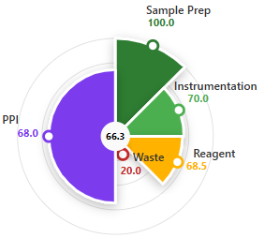 | 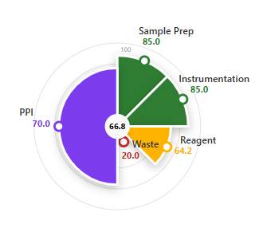 | 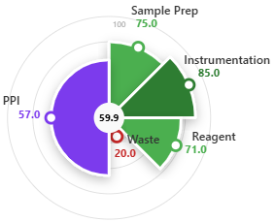 | 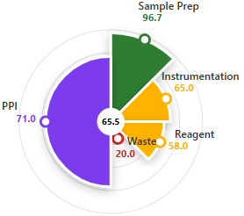 | 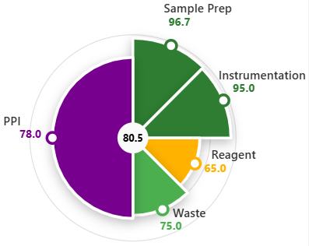
AGREE | 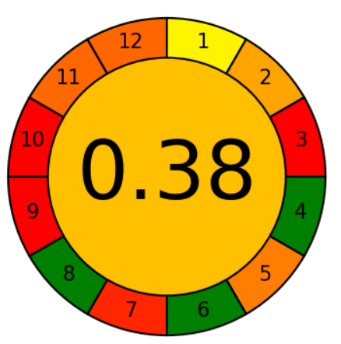 | 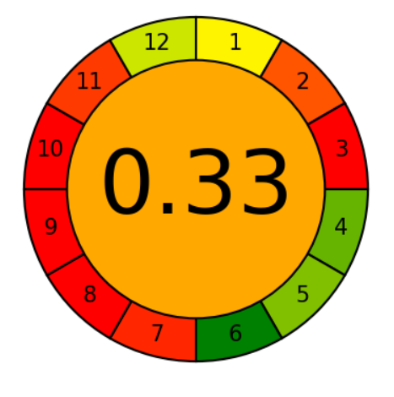 | 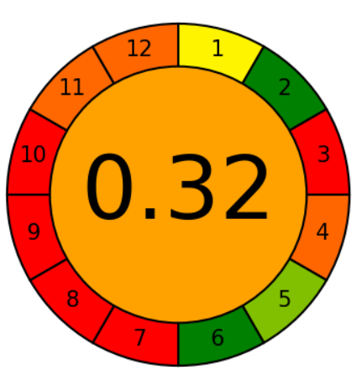 | 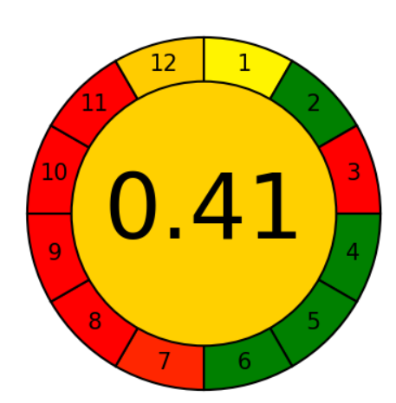 | 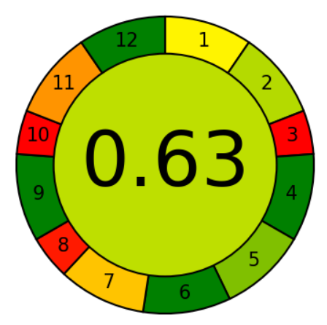
Complex GAPI | 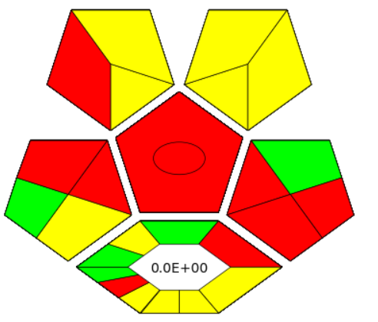 | 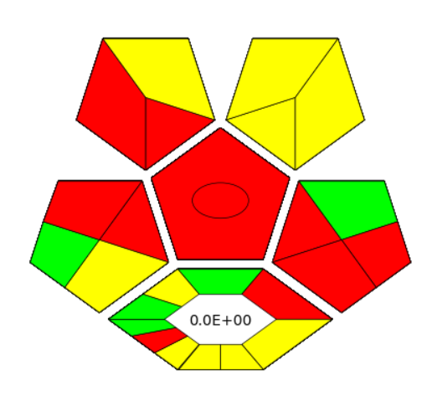 | 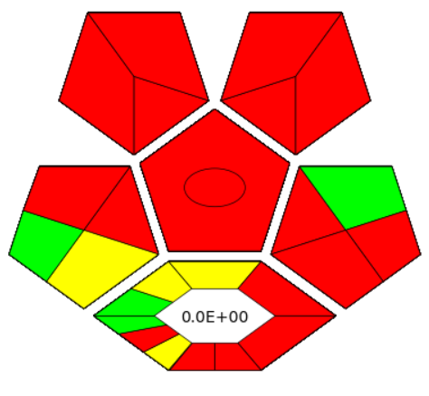 | 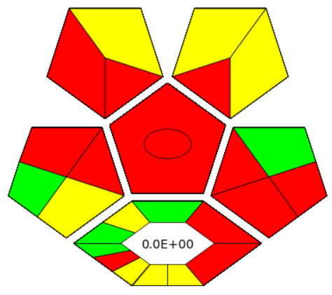 | 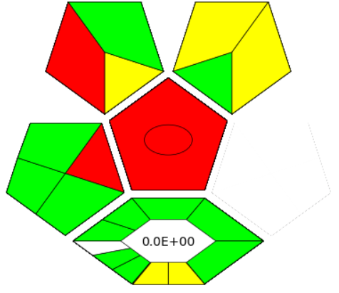
Technique | Liquid chromatography- tandem mass spectrometry (LC-MS/MS) | Ultra performance liquid chromatography (UPLC-DAD) | High-performance liquid chromatography (HPLC) | Liquid chromatography Diode array detector (LC/DAD) | Thin-layer chromatography image analysis (TLC-IA)
Sam Pre-treatment and Ext. Method | Electromembrane extraction (EME) | Liquid-liquid extraction (LLE) | Solid phase extraction (SPE) | Liquid-liquid extraction (LLE) | Ultrasonicator-assisted dispersive liquid-liquid microextraction (UA-DLLME)
Sample Matrix | Blood and urine | Human Plasma | Urine | Human serum | Blood, urine, and pill
Sr. No. | 1 | 2 | 3 | 4 | 5

- Conclusion:
The development of sustainable and eco-friendly methodologies has become a modern imperative. Research has increasingly pivoted toward Green Analytical Chemistry (GAC) principles to mitigate the use of hazardous reagents and excessive energy consumption. This study addresses these goals by employing DLLME, a technique that utilizes microliter-scale solvent volumes to meet green sample preparation standards.
Furthermore, integrating thin-layer chromatography (TLC) with digital image colorimetry eliminates the need for high-end, power-intensive instrumentation. This methodology is not only rapid and cost-effective but also offers superior sample throughput compared to traditional techniques. Its simplicity and lack of overnight preparation make it ideal for resource-limited laboratories and the detection of highly sensitive analytes.
Beyond its standalone applications, this approach is compatible with hyphenated systems like HPLC, GC-MS, and LC-MS, effectively reducing chemical waste during initial preparation phases. Evaluation metrics for greenness and practicability demonstrate that this method outperforms previous studies. Given its efficacy in processing minute evidence volumes—often restricted to µL or µg scales—it holds significant promise for forensic science and future analytical innovations.

- Declaration of competing interest:
There was no conflict of interest among the authors, and there were no known personal relationships and competing financial interests that could influence the work in any way possible.

- Acknowledgment:
The authors are grateful to the Dean of Sharda School of Allied Health Science and the Head of the Department for their continuous support and guidance and for providing facilities to carry out the present work. Financial support of this research by Sharda University, Greater Noida, India under the seed-fund scheme (Project No. SU/SF/2022/13) is gratefully acknowledged.

- Compliance with ethical standards:
The present study was carried out strictly in accordance with “National ethical guidelines from biomedical and health research involving human participants” approved by the Indian Council of Medical Research, New Delhi, and also approved by the Institutional Human Ethical Committee (Ref no. SU/SMS&R/76-A/2023/176).

8. References:
[1] Belova, M. V., Klyuyev, E. A., Melnikov, E. S., & Poryadina, M. N. (2020). Chemical and Toxicological Diagnosis of Acute Poisoning with Clozapine, Olanzapine, Quetiapine and Risperidone. Russian Sklifosovsky Journal “Emergency Medical Care,” 9(2), 188–194. https://doi.org/10.23934/2223-9022-2020-9-2-188-194
[2] Dedania, Z. R., Dedania, R. R., Sheth, N. R., Patel, J. B., & Patel, B. (2011). Stability Indicating HPLC Determination of Risperidone in Bulk Drug and Pharmaceutical Formulations. International Journal of Analytical Chemistry, 2011, 1–6. https://doi.org/10.1155/2011/124917
[3] Elman, I. (2002). Effects of Risperidone on the Peripheral Noradrenegic System in Patients with Schizophrenia A Comparison with Clozapine and Placebo. Neuropsychopharmacology, 27(2), 293–300. https://doi.org/10.1016/S0893-133X(02)00314-7
[4] Jain, R., Singh, R., Sudhaker, S. (2017). Coupling Microextraction With Thin Layer Chromatography-Image Processing Analysis: A New Analytical Platform for Drug Analysis. Toxicology and Forensic Medicine - Open Journal, 2(1), 17–25. https://doi.org/10.17140/TFMOJ-2-113
[5] He, Y., & Concheiro‐Guisan, M. (2019). Microextraction sample preparation techniques in forensic analytical toxicology. Biomedical Chromatography, 33(1), e4444. https://doi.org/10.1002/bmc.4444
[6] Jain, R. (2018). Optimization of ultrasound-assisted emulsification microextraction by experimental design for determination of over-the-counter drugs by thin-layer chromatography–image-processing method. JPC - Journal of Planar Chromatography - Modern TLC, 31(4), 265–271. https://doi.org/10.1556/1006.2018.31.4.1
[7] Jain, R., Jha, R. R., Kumari, A., & Khatri, I. (2021). Dispersive liquid-liquid microextraction combined with digital image colorimetry for paracetamol analysis. Microchemical Journal, 162, 105870. https://doi.org/10.1016/j.microc.2020.105870
[8] Jain, R., Tripathi, R. M., Negi, A., & Singh, S. P. (2020). A simple, cost-effective and rapid method for simultaneous determination of Strychnos nux-vomica alkaloids in blood and Ayurvedic medicines based on ultrasound-assisted dispersive liquid–liquid microextraction–thin-layer chromatography-image analysis. Journal of Chromatographic Science, 58(5), 477–484. https://doi.org/10.1093/chromsci/bmaa007
[9] Ji, W.-H., Guo, Y.-S., Wang, X., & Guo, D.-S. (2018). A water-compatible magnetic molecularly imprinted polymer for the selective extraction of risperidone and 9-hydroxyrisperidone from human urine. Talanta, 181, 392–400. https://doi.org/10.1016/j.talanta.2018.01.025
[10] Mennickent, S., Diego, M. D., Liser, B., & Trujillo, L. (2019). Simplified liquid-liquid extraction method coupled with lc/dad by quantitative determination of risperidone in human serum. Journal of the Chilean Chemical Society, 64(1), 4265–4267. https://doi.org/10.4067/s0717-97072019000104265
[11] Patel, R. B., Patel, B. G., Patel, M. R., & Bhatt, K. K. (2010). HPTLc method development and validation for analysis of risperidone in formulations, and in-vitro release study. Acta Chromatographica, 22(4), 549–567. https://doi.org/10.1556/AChrom.22.2010.4.5
[12] Siva Selva Kumar, M., & Ramanathan, M. (2016). Concurrent determination of olanzapine, risperidone and 9‐hydroxyrisperidone in human plasma by ultra performance liquid chromatography with diode array detection method: Application to pharmacokinetic study. Biomedical Chromatography, 30(2), 263–268. https://doi.org/10.1002/bmc.3545
[13] Yousefsani, B. S., Salimi, A., Imani, F., Ramezani, M., Shirani, K., Seydi, E., & Pourahmad, J. (2022). Risperidone Toxicity on Human Blood Lymphocytes in Nano molar Concentrations. Drug Research, 72(06), 343–349. https://doi.org/10.1055/a-1830-8701
[14] Yu, X., Li, X., You, S., Shi, Y., Zhu, R., Dong, Y., & Huang, C. (2020). Electromembrane extraction of chlorprothixene, haloperidol and risperidone from whole blood and urine. Journal of Chromatography A, 1629, 461480. https://doi.org/10.1016/j.chroma.2020.461480
[15] Akash, M.S.H. and Rehman, K., 2025. Comprehensive insights into thin layer chromatography. In Essentials of Pharmaceutical Analysis (pp. 577-619). Singapore: Springer Nature Singapore.
[16] Siegel, J.A. ed., 2015. Forensic chemistry: fundamentals and applications. John Wiley & Sons.
[17] Maślanka, A., Krzek, J., & Patrzałek, A. (2009). Determination of risperidone in tablets in the presence of its degradation products and placebo-derived constituents. Acta Poloniae Pharmaceutica, 66(5), 461-470.
[18] Płotka-Wasylka, J. (2018). A new tool for the evaluation of the analytical procedure: Green Analytical Procedure Index. Talanta, 181, 204-209. https://doi.org/10.1016/j.talanta.2018.01.013
[19] Pena-Pereira, F., Wojnowski, W., & Tobiszewski, M. (2020). AGREE—Analytical GREEnness metric approach and software. Analytical chemistry, 92(14), 10076-10082. https://doi.org/10.1021/acs.analchem.0c01887
[20] Elagamy, S. H., Kannaiah, K. K. P., Chanduluru, H. K., Yahaya, N., & Obaydo, R. H. (2025). EPPI: A comprehensive index framework for assessment of sustainability performance, and practicality of analytical methods. Green Analytical Chemistry, 100306. https://doi.org/10.1016/j.greeac.2025.100306
[21] Rezaee, M., Assadi, Y., Hosseini, M. R. M., Aghaee, E., Ahmadi, F., & Berijani, S. (2006). Determination of organic compounds in water using dispersive liquid–liquid microextraction. Journal of Chromatography a, 1116(1-2), 1-9. https://doi.org/10.1016/j.chroma.2006.03.007

